LAB MANUAL

COMPUTER NETWORKS
ITCN – 328 v.7



DEPARTMENT OF INFORMATION TECHNOLOGY
FACULTY OF ENGINEERING & COMPUTING
NATIONAL UNIVERSITY OF MODERN LANGUAGES
ISLAMABAD

Preface
This lab manual has been prepared to facilitate the students of software engineering in studying and implementing the layered approach in data communications, switching technologies, and protocols of networking. It will assist students in designing via simulation of various routing protocols and services, like DNS, WWW, DHCP, FTP, etc., using Cisco’s packet tracer. These labs would also be helpful to develop expertise, such as the designing, optimization, and maintenance of various types of networks. As part of the course, the labs will help learn about the planning aspect of the networks by implementing IPv4 addresses, and understanding the addressing schemes will guide students to learn about LAN (private) and WAN (public) addressing and subnetting and super-netting concepts. Similarly, students will learn about different types of LAN cables, troubleshooting a network, network devices, security implementation, and technologies to assist in the smooth running of networks and related issues.

Tools/ Technologies

- Crimping tool, wire stripper, Cable tester.
- Gen 8 or above PC or laptop.
- Windows 10 or higher OS.
- Cisco Packet Tracer latest ver.
Note: Students may register him/herself on the Cisco web site using a link https://id.cisco.com/. Similarly, it is recommended that a student download the latest version from the site too.

About Packet Tracer

Packet Tracer is a simulation, visualization, collaboration, and assessment tool for teaching networking. It allows students to construct their model or virtual networks, obtain access to important graphical representations of those networks, animate those networks by adding their own data packets, ask questions about those networks, and finally annotate and save their creations.

TABLE OF CONTENTS

Preface i
Tools/ Technologies i
About Packet Tracer i
LAB 1: Preparing Ethernet Cables 1
LAB 2: Understanding Network Commands 10
LAB 3: IP Addressing and Subnetting 20
LAB 4: Configuring Basic Switch and Router 27
LAB 5: Securing the Switch and Router 38
LAB 6: Virtual LAN (VLANs) 46
LAB 7: Cisco Discovery Protocol (CDP) and Servers 56
LAB 8: Open-Ended Lab 67
LAB 9: Switch Redundant connections and Loops (STP) 68
LAB 10: Configuring Static Routing 70
LAB 11: Configuring WAN Connection and Default Routes 72
LAB 12: Setting up Dynamic Routing Protocol RIP v1 and v2 76
LAB 13: Simulation of IoT based Home Automation 81
LAB 14: Programming and controlling the IoT devices using MCU and SBC 88
Appendix ‘A’ Writing a Lab Report 96
Appendix ‘B’ Evaluation Rubrics 100

LAB 1: Preparing Ethernet Cables

Objectives
- Understand different types of communication cables for LAN.
- How to wire Ethernet cables and connect them to RJ45 jacks.
- Understand the color combinations of UTP cables.
- Understand the limitations of the UTP cables.
- How to use the tools to prepare the Ethernet cables.

Tools required: -
- Cable - bulk Category 5e, 6 and 6e
- Wire Cutters - to cut the cable if necessary.
- Wire Stripper - to strip the cable if necessary.
For Patch Cables (connect switches):
- RJ45 Plugs
- RJ45 Crimper
For Fixed Wiring:
- RJ45 Jacks
Recommended:
- Wire Stripper
- Cable Tester

- Introduction: About the Cable
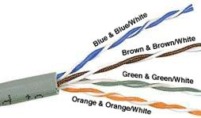
You can find bulk supplies of the cable at many computer stores or most electrical or home centers. UTP (Unshielded Twisted Pair) Category 5e cables are used for basic 10/100 Mbps functionality and CAT 5e and 6 for gigabit also called 1000BaseT operation, and CAT 7 gives you a measure of future-proofing with 10 gigabits per second transmission.
Bulk cable comes in many types, and there are two basic categories, solid and braided cable. Braided cable tends to work better in patch applications for desktop use. It is more flexible and resilient than solid cable and easier to work with but meant for shorter lengths. Solid cable is meant for longer runs in a fixed position.
The plenum-rated cable must be used whenever the cable travels through an air circulation space, for example, above a false ceiling or below a raised floor. It may be difficult or impossible to tell from the package what type of cable it is, so peal out an end and investigate and look inside the cable. Usually, there are eight color-coded wires. These wires are twisted into four pairs of wires, and each pair has a common color theme. Plenum-rated (CMP) cable has an outer jacket made of fire-resistant material like Teflon to prevent fire from spreading. When a fire happens, plenum-rated cable is designed to: Restrict flame propagation to no more than five feet. Limit the amount of harmful smoke released
One wire in the pair is a solid or primarily solid-colored wire, and the other is a primarily white wire with a colored stripe. Examples of the naming schemes used are Orange (alternatively Orange/White) for the solid-colored wire and White/Orange for the striped cable. The twists are extremely important. Twisting is there to counteract noise and interference.
1.1 Preparing a cable
It is important to wire according to a standard to get proper performance from the cable. The TIA/EIA-568-A specifies two wiring standards for an 8 or 4-position modular connector such as RJ45 also known as 8P4C (100Mbps) or 8P8C (1000Mbps). The two wiring standards, T568A and T568B vary only in the arrangement of the colored pairs.
Your choice might be determined by the need to match existing wiring, jacks, or personal preference, but you should maintain consistency. I've shown connections of 568B standard in Figures 1.4 and 1.5 for straight-through and crossover cabling. But before we jump into standards, the next section will focus on some important details first.
1.2 Cable pairs by color coding
Each twisted pair of cabling in the UTP cable is color-coded for easy identification. In North America, each wire in a twisted pair is identified by one of 5 colors: blue, orange, green, brown, or slate (gray). Then this copper wire is paired with a different wire from the other color group made up of white, red, black, yellow, or violet. Usually, one copper wire in a twisted pair is solid-colored, and the second one is striped with the color of its mate. Ex: A solid blue-colored copper cable is paired with a white and blue striped copper cable. It will make it easy to identify and match them. Alexander Graham Bell invented this twisted pair of cabling in 1881.
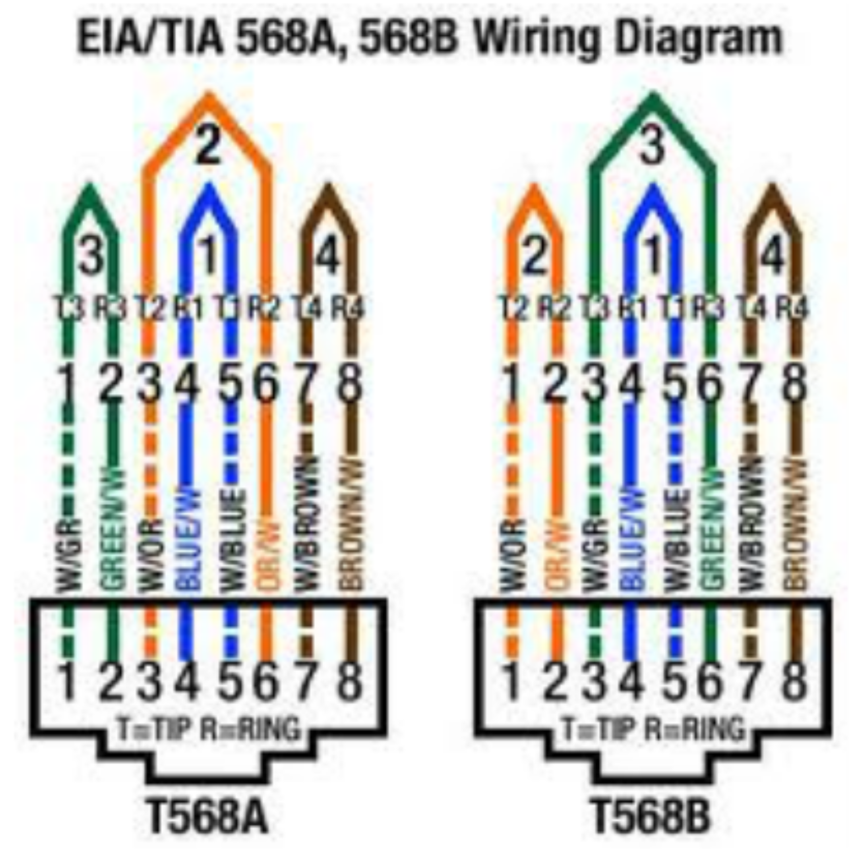
Fig 1.0 UTP color pairs and 568A and 568B standards

- Introduction to RJ45 Plugs or Jacks:
An 8-pin/8-position plug or jack is commonly used to connect computers to Ethernet-based local area networks (LAN), as shown in Figure 1.1. There are a couple of variations available. The primary variation students need to pay attention to is whether the connector is intended for braided or solid wire.
For braided/stranded wires, the connector has sharp pointed contacts that pierce the wire.
For solid wires, the connector has fingers that cut through the insulation and contact the wire by grasping it from both sides.
The connector is the weak point in an ethernet cable; choosing the wrong one will often cause grief later. If you just walk into a computer store, it's nearly impossible to tell what type of plug it is. You may be able to determine what type it is by crimping one without a cable.
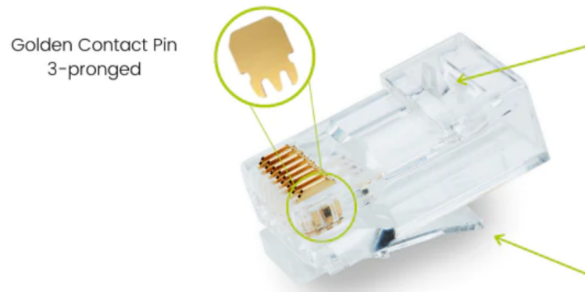
Figure 1.1 RJ45 Plug or Jack

RJ45 jacks come in a variety of styles intended for several different mounting options. The choice is one of the requirements and preferences. RJ45 jacks are designed to work only with solid cable. Most jacks come labeled with color codes for either T568A, T568B, or both.

- Forms of Ethernet Cables - Crossed and Straight cables: When to use them
The following diagram shows the Normal use of Crossed and Straight cables (see figure 1.2).
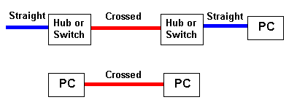
Figure 1.2 Type of Ethernet cables
Notes:
- We show Straight cables as BLUE and Crossed as RED. That is our convention; the cable color can be anything you choose or, more likely, the vendor decides.
- To avoid the need for Crossed cables, many vendors provide UPLINK ports on Hubs or Switches - these are specially designed to allow the use of a STRAIGHT cable when connecting back-to-back Hubs or Switches. Read the manufacturer's documentation carefully.
- Ethernet Cable Pin Outs and Connections
There are two basic cable pinouts. A straight-through cable is used to connect to a hub or Switch, and a crossover cable is used to operate in a peer-to-peer fashion without a hub/switch.
Generally, all fixed wiring should be run straight through. Some ethernet interfaces can cross and un-cross a cable automatically as needed, a handy feature.

NOTE: Standard, Straight-Through Wiring (both ends are the same):
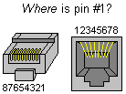
Let's first learn how to find the PIN No. of the Connector. Make sure you identify and start with the correct Pin.

Figure 1.3 Pinout of connector
- What Is Straight Through Cable?
A straight-through cable is a type of twisted pair cable that is used in local area networks to connect a computer to a network hub such as a router. This type of cable is also sometimes called a patch cable and is an alternative to wireless connections where one or more computers access a router through a wireless signal. On a straight-through cable, the wired pins match. Straight-through cable uses one wiring standard: both ends use the T568A wiring standard, or both ends use the T568B wiring standard. The following figure shows a straight-through cable of which both ends are wired as the T568B standard.
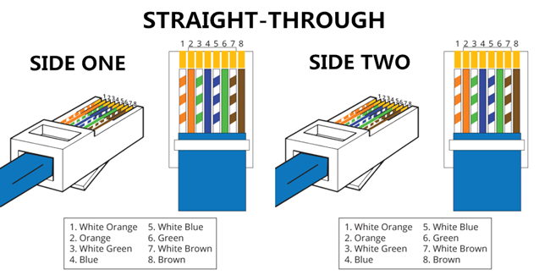
Figure 1.4 Straight-Through cable connections
- What Is Crossover Cable?
A crossover Ethernet cable is a type of Ethernet cable used to connect computing devices directly. Unlike straight-through cable, the RJ45 crossover cable uses two different wiring standards: one end uses the T568A wiring standard, and the other end uses the T568B wiring standard. The internal wiring of Ethernet crossover cables reverses the transmit and receive signals. It is most often used to connect two devices of the same type: e.g., two computers (via network interface controller) or two switches to each other.
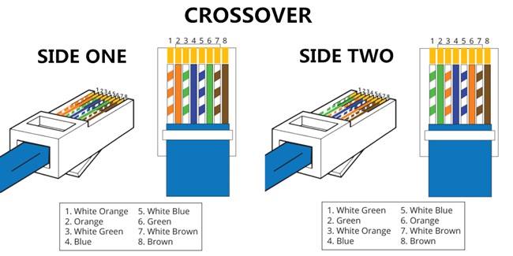
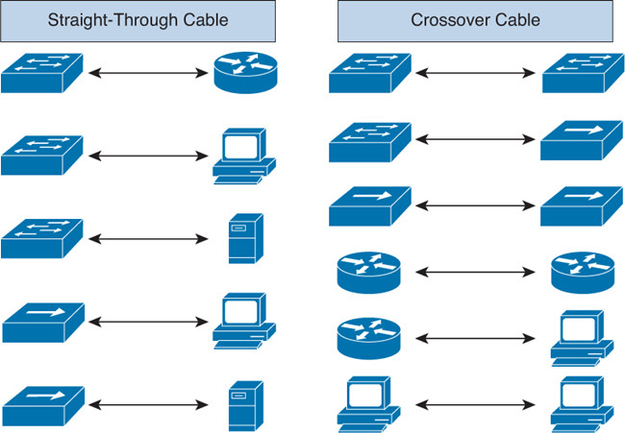
Figure 1.5 Crossover Cable

- Straight Through vs. Crossover Cable, which to choose?

Straight through vs. crossover cable, which one should I choose? Usually, straight-through cables are primarily used for connecting, unlike devices. And crossover cables are used for connecting like devices.

Use straight-through Ethernet cable for the following cabling:
- Switch to Router
- Switch to PC or server

- Hub to PC or server
Use crossover cables for the following cabling:
- Switch to switch
- Switch to Hub
- Hub to Hub
- Router to Router
- Router Ethernet port to PC NIC
- PC to PC

- Pin Out Tables for ethernet and fast ethernet connections
Straight-Through Cable Pin Out for T568A (8P8C)
RJ45 Pin # | Wire Color  (T568A) | Wire Diagram  (T568A) | 10Base-T Signal  100Base-TX Signal | 1000Base-T Signal
1 | White/Green |  | Transmit+ | BI_DA+
2 | Green |  | Transmit- | BI_DA-
3 | White/Orange |  | Receive+ | BI_DB+
4 | Blue |  | Unused | BI_DC+
5 | White/Blue |  | Unused | BI_DC-
6 | Orange |  | Receive- | BI_DB-
7 | White/Brown |  | Unused | BI_DD+
8 | Brown |  | Unused | BI_DD-

Straight-Through Cable Pin Out for T568B (8P8C)
RJ45 Pin # | Wire Color  (T568B) | Wire Diagram  (T568B) | 10Base-T Signal  100Base-TX Signal | 1000Base-T Signal
1 | White/Orange |  | Transmit+ | BI_DA+
2 | Orange |  | Transmit- | BI_DA-
3 | White/Green |  | Receive+ | BI_DB+
4 | Blue |  | Unused | BI_DC+
5 | White/Blue |  | Unused | BI_DC-
6 | Green |  | Receive- | BI_DB-
7 | White/Brown |  | Unused | BI_DD+
8 | Brown |  | Unused | BI_DD-

Cross Over Cable (T568B):
RJ45 Pin # (END 1) | Wire Color | Diagram  End #1 | RJ45 Pin # (END 2) | Wire Color | Diagram  End #2
1 | White/Orange |  | 1 | White/Green
2 | Orange |  | 2 | Green
3 | White/Green |  | 3 | White/Orange
4 | Blue |  | 4 | White/Brown
5 | White/Blue |  | 5 | Brown
6 | Green |  | 6 | Orange
7 | White/Brown |  | 7 | Blue
8 | Brown |  | 8 | White/Blue
Note: The crossover cable layout is suitable for 1000Base-T operation; all four pairs are crossed.

- How to wire Ethernet Patch Cables:
- Strip off about 2 inches of the cable sheath.
- Untwist the pairs - don't untwist them beyond what you have exposed; the more untwisted cable you have, the worse the problems you can run into.
- Align the colored wires according to the diagrams above.
- Trim all the wires to the same length, about 1/2" to 3/4" left exposed from the sheath.
- Insert the wires into the RJ45 plug - make sure each wire is fully inserted into the front of the RJ45 plug and in the correct order. The sheath of the cable should extend into the RJ45 plug by about 1/2" and will be held in place by the crimp.
- Crimp the RJ45 plug with the crimper tool.
- Verify the wires ended up in the right order and that the wires extend to the front of the RJ45 plug and make good contact with the metal contacts in the RJ45 plug
- Cut the cable to length - make sure it is more than long enough for your needs.
- Repeat the above steps for the second RJ45 plug.
- How to wire fixed Ethernet Cables:
- Run the full length (Max 100 meters) of cable in place, from endpoint to endpoint, making sure to leave excess.
- At one end, cut the wire to length, leaving enough length to work but not too much excess.
- Strip off about 2 inches of the cable sheath.
- Align each of the colored wires according to the layout of the jack.
- Use the punch-down tool to insert each wire into the jack.
- Repeat the above steps for the second RJ45 jack.
- Precautions While Preparing Cable
If a cable tester is available, use it to verify the proper connectivity of the cable. That should be it; if your cable doesn't turn out, look closely at each end and see if you can find the problem. Often a wire ends up in the wrong place, or one of the wires is making no contact or poor contact.
Also, double-check the color coding to verify it is correct. If you see a mistake or problem, cut the end off and start again. A cable tester is invaluable at identifying and highlighting these issues.
When sizing cables, remember that an end-to-end connection should not extend more than 100m (~328ft). Try to minimize the cable length; the longer the cable becomes, the more it may affect performance. This is usually noticeable as a gradual decrease in speed and increase in latency.
- Ethernet Technologies
In computer networking, Fast Ethernet physical layers communicate at the nominal rate of 100 Mbps, whereas, its successor Ethernet speed was originally 10 Mbit/s.
12.1 Ethernet over Twisted pair cables
An Ethernet cable is a common type of network cable used with wired networks. Ethernet cables connect devices such as PCs, routers, and switches within a local area network.
These physical cables are limited by length and durability. If a network cable is too long or of poor quality, it won't carry a good network signal. These limits are one reason different types of Ethernet cables are optimized to perform certain tasks in specific situations.
100BASE-TX and 100BASE-T4, are the technical name of Fast Ethernet over twisted pair cables. It is a predominant form of Fast Ethernet carrying data traffic at 100 Mbps (Mega bits per second) in local area networks (LAN). 100 Mbps, BASE denoted the use of baseband transmission, and TX and T4 denote the use of twisted pair cables in Fast Ethernet.100 Mbps, where T4 denotes the use of four twisted pair cables in Fast Ethernet.
Ethernet over Fiber optic cables
100BASE-FX is the technical name of Fast Ethernet over fiber optic cables. 100 Mbps, BASE denoted the use of baseband transmission, and FX denotes the use of optical fibers in Fast Ethernet.
All the above standards of Ethernet are launched as the IEEE 802.3u standard in 1995. Here, 100 is the maximum throughput, i.e.

Lab Task (Part A)

During the lab, a student has to take pictures of the tools they are using and the procedure of preparing the cable and preparing the report task.

Lab Task (Part B)

- Prepare the ethernet cable during the lab. Explain the steps and attach the pictures of the equipment and steps performed with the Lab 1 report.

- Perform the Lab task and attach it along with the lab report while submitting.
- Identifying the pins on the RJ45 male connector, which are used for transmission of 100 Mbps.
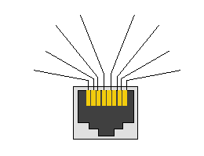
Identify The Color Pairs
PAIR NO 1 _____________________
PAIR NO 2 _____________________
PAIR NO 3 _____________________
PAIR NO 4 _____________________

- Correctly number the pins of the jack
5. Label the pins according to the color coding schemes
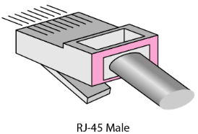

- Provide a correct color code of the connector for 568b standard.
Straight Cable Cross Cable
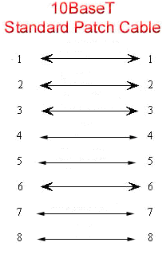
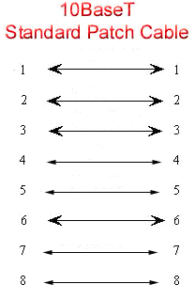

LAB 2: Understanding Network Commands

Objectives
- Gather information including connection, hostname, Layer 2 MAC address, and Layer 3 TCP/IP network address information.
- Compare network information to other PCs on the network.
- Learn to use the TCP/IP Packet Internet Groper (ping) command from a workstation.
- Learn to use the Trace Route (tracert) command from a workstation.
- Observe name resolution occurrences using WINS and/or DNS servers.

- Introduction
This lab assumes the use of command prompt Windows 10 and above. This is a non-destructive lab and can be done on any machine without concern about changing the system configuration. Ideally, this lab is performed in a Computer Lab or other LAN environment that connects to the internet.
The commands help us to diagnose the LAN environment and troubleshoot the network. The following command will be used to practice during the lab, Ensuring the computer has an IP address:

- Ping
- Trace Route
- ARP
NOTE: The command prompt (CMD) is displayed in black color. Students are advised not to use the black background diagrams in reports, instead change the color and then paste figures.

How to change the color of COMMAND PROMPT

- COLORXY - Specifies color attribute of console output
- Color attributes are specified by TWO hex digits -- the first corresponds X to the background; the second Y is the foreground.
- Each digit can be any of the following values:
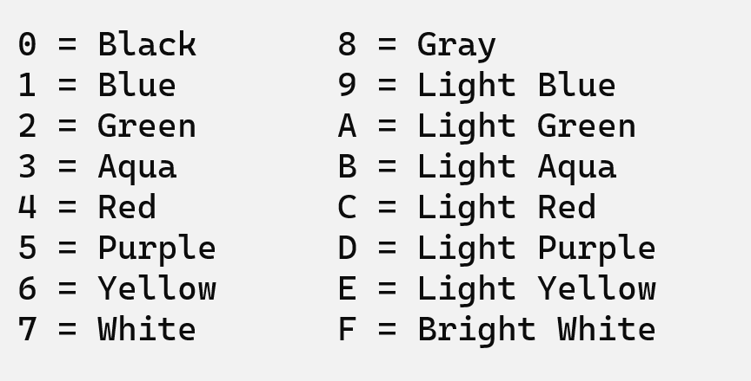
To change the color of the CMD use the following command

C:\Users\Hasan Shah>COLOR F0

A. Understanding the computer’s Local area connections

Step 1 Connect to the Network
Establish and verify connectivity to the internet using a network device like a switch or router. This ensures the computer has an IP address.

Step 2 Gather TCP/IP configuration information
Use the Start menu to open the Command Prompt, an MS-DOS-like window.
Press Windows + R Key, Then type cmd.

Task 1 IPCONFIG
Type ipconfig and press the Enter key. The spelling of ipconfig is critical, while the case is not. It is short for IP Configuration.

This first screen shows the IP address, subnet mask, and default gateway. The IP address and the default gateway should be in the same network or subnet. Otherwise, this host would not be able to communicate outside the network. In figure 2.1, the subnet mask tells us that the first three octets must be the same to be in the same network. Further understanding of IP addresses shall be taught in Lab 3.

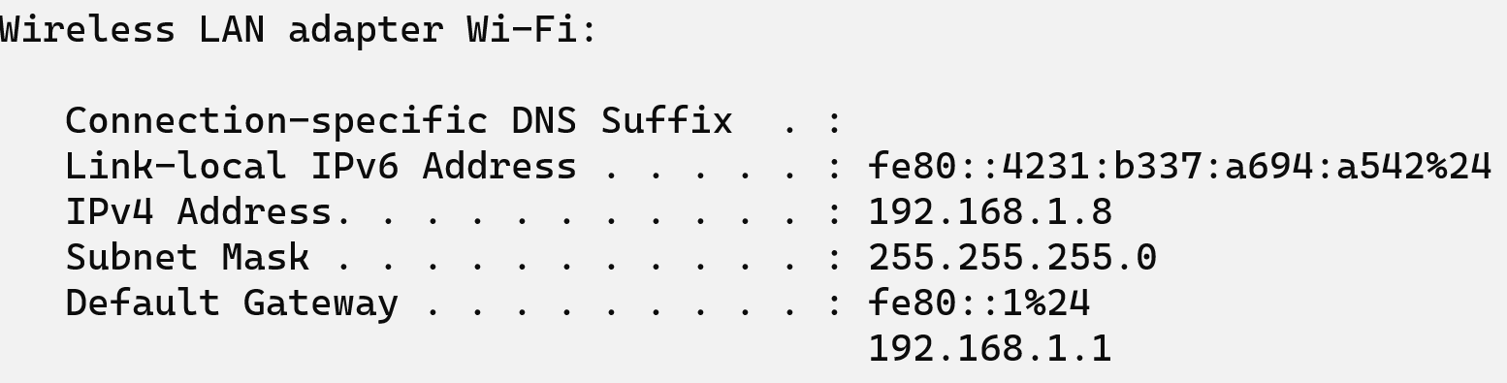
Figure 2.1 IPconfig command

Note: If this computer is on a LAN, the default gateway might not be seen, if it is running behind a Proxy Server. Record the following information for this computer.

Record the following TCP/IP information for this computer

IP address: ________________________________________________________
Subnet Mask: ______________________________________________________
Default Gateway: ___________________________________________________
Record a couple of the IP Addresses:_______________________________________

Task 2 Check additional TCP/IP configuration information
To see detailed information, type ipconfig /all and press Enter.
Figure 2.2 shows the detailed IP configuration screen of multiple Ethernet adaptors connected to the Computer. Choose an adaptor accordingly.

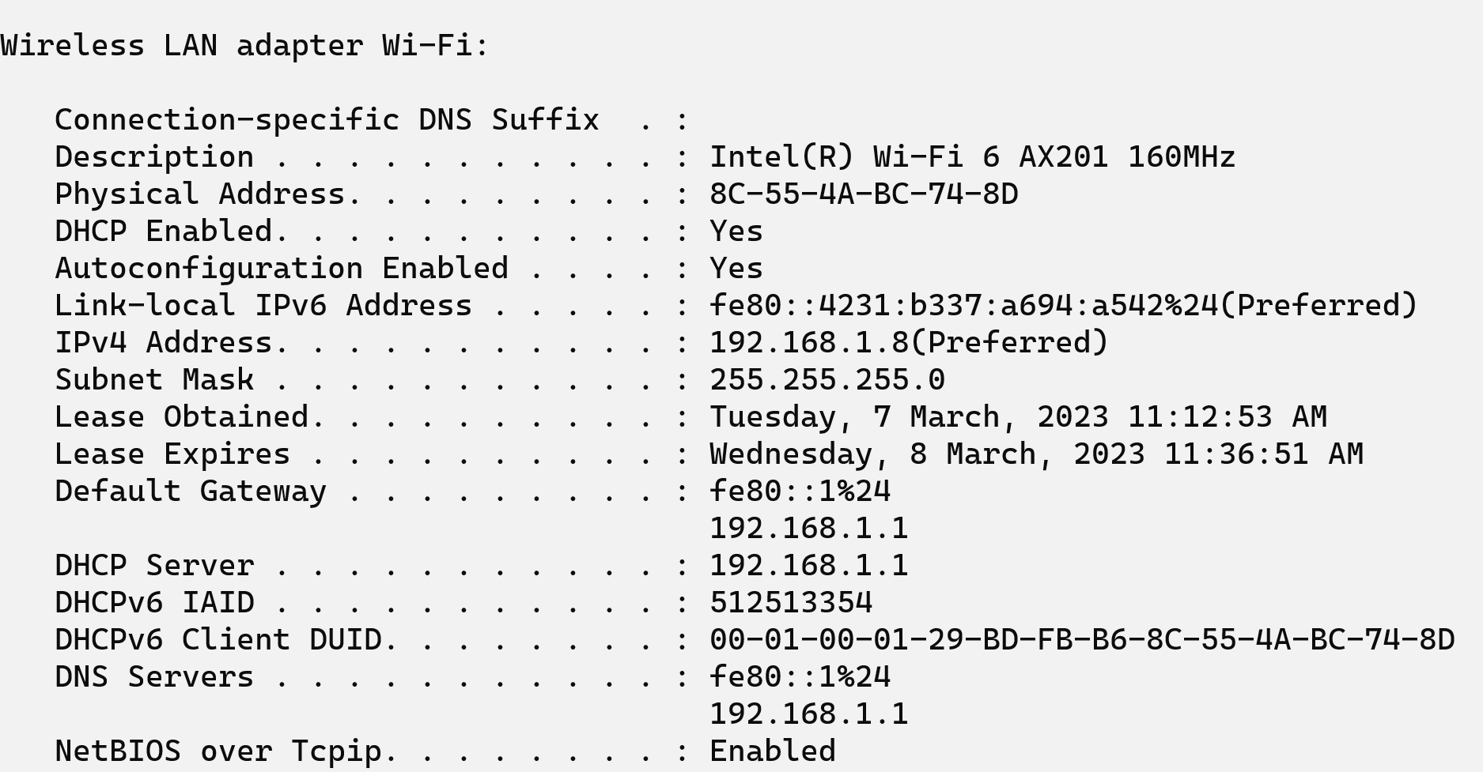
Figure 2.2 Ipconfig /all

Figure 2.2 shows WiFi adaptor information. It shows the IP address of the machine, its subnet mask, its MAC address (Physical addresses) including the DHCP server address, and the date the IP lease starts and ends should be displayed. Looking over the information we can see the Default gateway entry to connect to the internet.

Close the screen
Close the screen when finished examining network settings.
Repeat the previous steps as necessary.

Reflection
Based on the above observations, what can be deduced about the following results taken from three computers connected to one Switch?
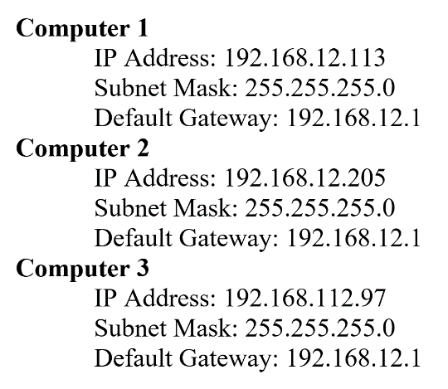

Should they be able to talk to each other?

_______________________________________
Are they all on the same network?

________________________________________
Why or why not? If something is wrong, what is most likely the problem
__________________________________

B. ICMP commands "ping" and "tracert "

Objective
- Learn to use the TCP/IP Packet Internet Groper (ping) command.
- Learn to use the Trace Route (tracert) command.

PING Background
This lab assumes the use of any Windows 10 and above version. This is a non-destructive lab and can be done on any machine without concern about changing the system configuration. Ideally, this lab is performed in a LAN environment that connects to the internet. It can be done from a single remote connection via a modem or DSL-type connection. The student will need the IP addresses that were recorded in the previous part of the lab.

Step 1 Establish and verify connectivity to the internet
This ensures the computer has an IP address.
Step 2 Access the command prompt
As accessed in the previous part of the lab. Press the windows button and type cmd

Task 1
Ping the IP address of another computer
In the CMD window, type ping, a space, and the IP address of a computer recorded in the previous lab. The following figure shows the successful results of ping to this IP address.

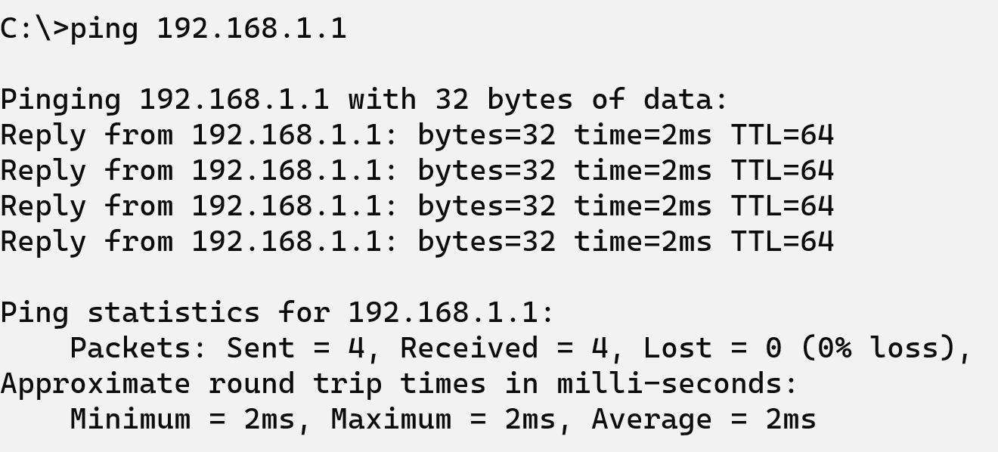
Figure 2.3 Ping Command reply
ping uses the ICMP echo and reply feature to test physical connectivity. Since the ping reports four attempts, it indicates the reliability of the connection. Look over the results and verify that the ping was successful.

Is the ping successful? _____________________________

Step 4 ping the IP address of the default gateway
Try to ping the IP address of the default gateway if one was listed in the last exercise. If the ping is successful, it means there is physical connectivity to the Router on the local network and probably the rest of the world.

Step 5 ping the IP address of a DHCP or DNS servers
Try to ping the IP address of any DHCP and/or DNS servers listed in the last exercise.
If this works for either server, and they are not in the network,

What does this indicate?______________________

Was the ping successful? ____________________

Step 6 ping the Loopback IP address of this computer
Loopback address helps to identify if the NIC of the computer is working fine or if it is faulty.
Type the following command: ping 127.0.0.1

The 127.0.0.0 network is reserved for loopback testing. If the ping is successful, then TCP/IP is properly installed and functioning on this computer.

Was the ping successful? ____________________

Step 7 ping the hostname of another computer
Try to ping the hostname of the computer that was recorded in the previous lab. The figure shows the successful result of the ping of the hostname.

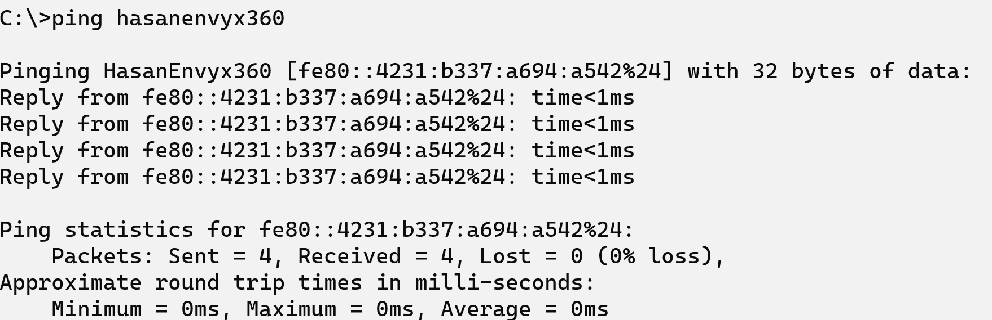
Figure 2.4 Pinging hostname

Look over the results. Notice that the first line of output shows the hostname, m450, in the example, followed by the IP address. This means the computer was able to resolve the hostname to an IP address. Without name resolution, the ping would have failed because TCP/IP only understands valid IP addresses, not names.
If the ping was successful, it means that connectivity and discovery of IP addresses can be made with only a hostname. This is how many early networks communicated. If successful, then ping a hostname also shows that there is probably a WINS server working on the network.

Step 8 ping the Cisco website Type the following command: ping www.cisco.com

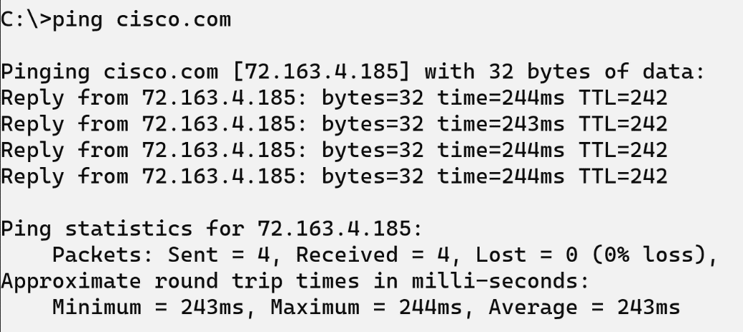

Figure 2.5 Ping Cisco.com

The first output line shows the Fully Qualified Domain Name (FQDN) followed by the IP address. A Domain Name Service (DNS) server somewhere in the network was able to resolve the name to an IP address. DNS servers resolve domain names, not hostnames, to IP addresses.
Without this name resolution, the ping would have failed because TCP/IP only understands valid IP addresses. It would not be possible to use the web browser without this name resolution.
With DNS, connectivity to computers on the internet can be verified using a familiar web address, or domain name, without having to know the actual IP address. If the nearest DNS server does not know the IP address, the server asks for a DNS server higher in the Internet structure.

Step 9 ping the Microsoft website
Type the following command: ping www.microsoft.com

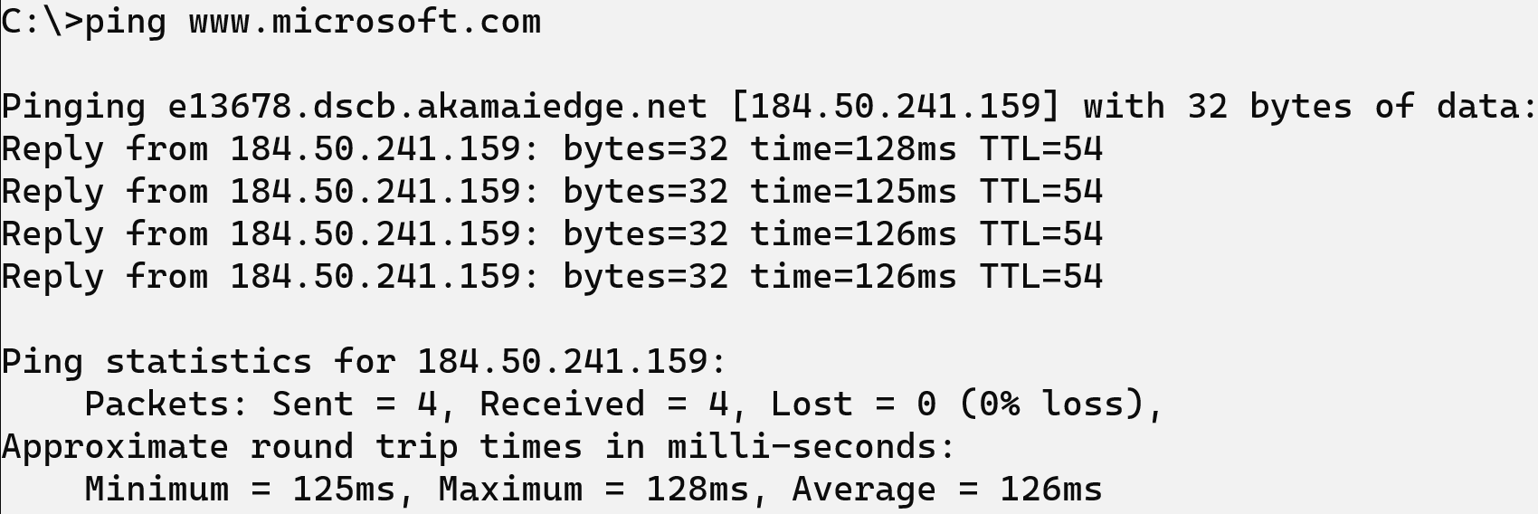
Figure 2.6 Ping www.Microsoft.com

Notice that the DNS server was able to resolve the name to an IP address, but there is no response.
Some Microsoft routers are configured to ignore ping requests. This is a frequently implemented security measure.

Ping some other domain names and record the results. For example, ping www.msn.de

Trace the route to the Cisco website

Step 1: Type tracert www.cisco.com and press Enter.

Tracert is TCP/IP abbreviation for traceroute. The preceding figure shows the successful result when running a tracert from Bavaria in Germany. The first output line shows the FQDN followed by the IP address. Therefore, a DNS server was able to resolve the name to an IP address. Then there are listings of all routers the tracert requests had to pass through to get to the destination.

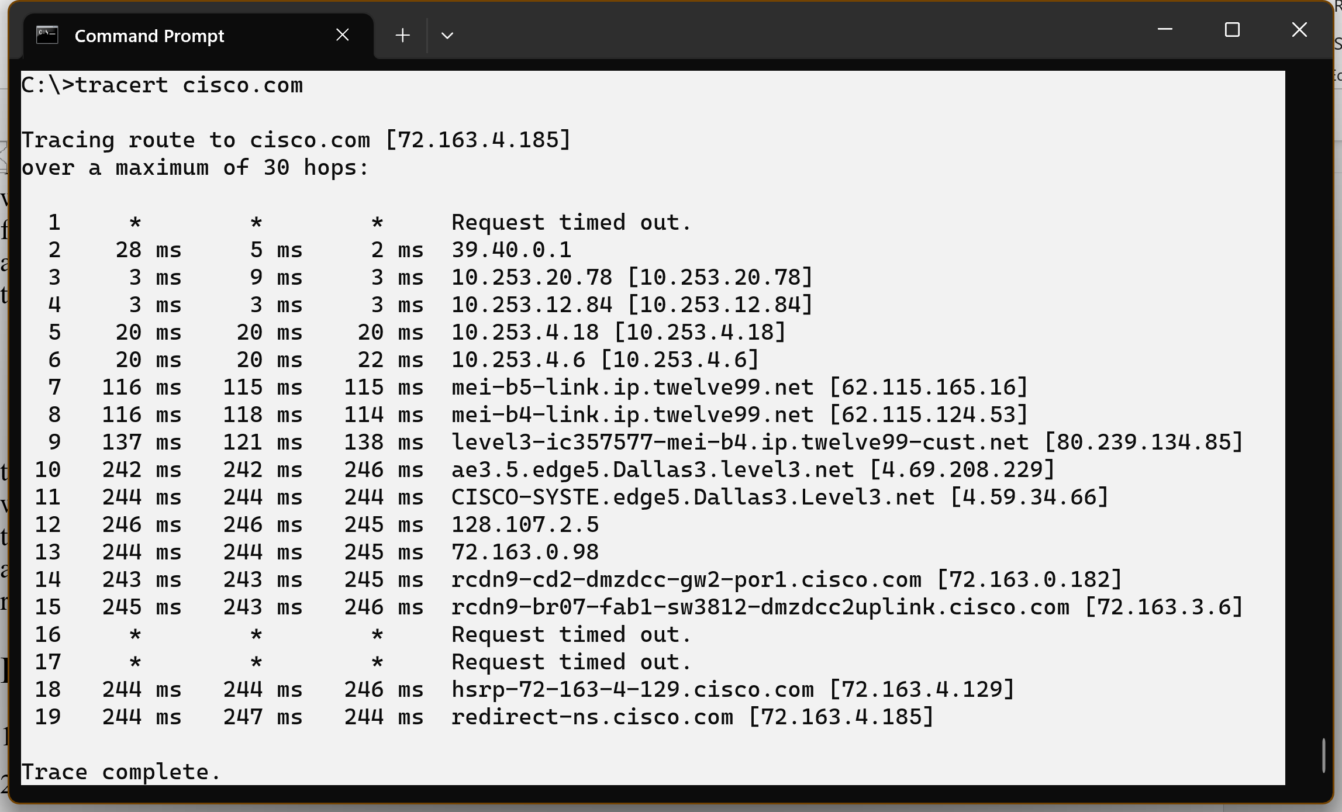
Figure 2.6 Tracert to Cisco.com

Tracert uses the same echo requests and replies as the ping command but in a slightly different way. Observe that tracert contacted each Router three times. Compare the results to determine the consistency of the route. Notice in the above example that there were relatively long delays after routers 11 and 13, possibly due to congestion. The main thing is that there seems to be a relatively consistent connection.

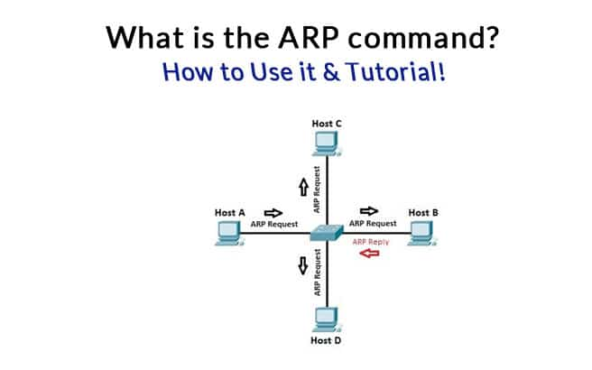
C. What is the ARP command?

ARP stands for “Address Resolution Protocol” and is a protocol for mapping an IP address to a physical MAC address on a local area network.

ARP is a program used by a computer system to find another computer’s MAC address based on its IP address. Now you have a question “why do we need MAC address?”

The reason is simple, any local communications would use a MAC address, not an IP address.

When a computer wants to communicate with another computer on a different network, the IP address would be used. The IP address is like your mailing address while the MAC address is like your name.
On a TCP/IP network, every computer is assigned an IP address, and some local server’ IP addresses are also given to a network client. Now you’re probably wondering – “How often does your computer use ARP?”.

To demonstrate how ARP works let’s take an example.
On a local area network, a client computer tries to contact a server. Here we are talking about communication between two computers on the same broadcast domain means a local area network. First, the client checks its ARP cache.

ARP cache is a table of IP addresses with their corresponding MAC addresses.
To view a Windows computer’s ARP table, open a command prompt and enter the following command:

C:\Users\Hasan Shah>arp -a

You can see your computers ARP table in the following output:

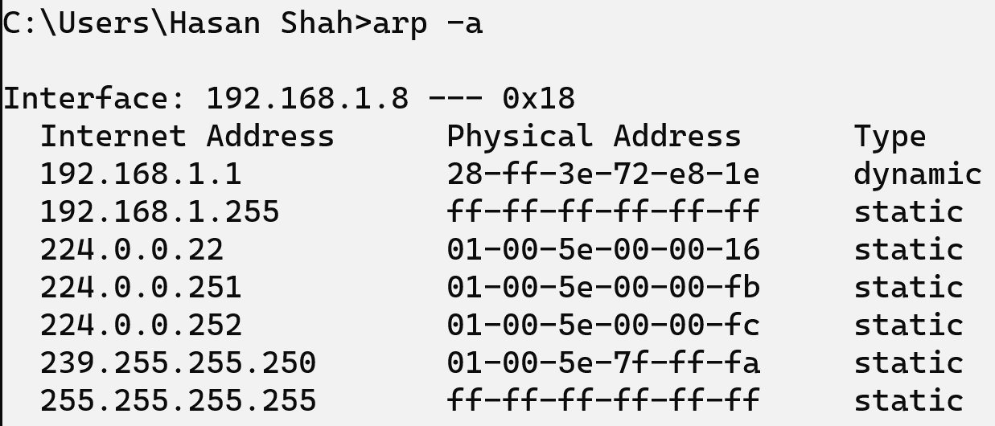

The first column is the IP address, and the second column is corresponding to the MAC address.

The ARP entry is either static or dynamic. Static ARP entry is manually added to the ARP cache table. Dynamic entries are what the ARP program gets. They stay there until the ARP cache timeout has expired. Suppose no entry has been found for the server, the client computer will use ARP to send a message through the whole network.

This is a broadcast message to the local network that says who has the IP address so and so, and whats your MAC address. When a server hears the broadcast message, they respond “yes” I have that IP address, and here is my MAC address.

Now, let’s Break down the ARP Process Step by Step:

- The client sends a broadcast message because the destination MAC address is a broadcast address. Simply saying hello! anyone has an IP address 192.168.1.8 if you hear me would you please give me your MAC address?, and here are my IP address and MAC address. Other devices hear the broadcast message and discard the ARP packet silently.
- When a server hears the message, it sends a unicast message to the client because the destination MAC address and IP address belong to the client.
- The client cache the server's MAC address. At the same time, the client updates its cache table for future reference.

ARP Summary
It is a layer 2 protocol that uses a layer 3 IP address to find the layer 2 MAC address.
It operates on a LAN or the same broadcast domain because ARP relies on broadcasting.
It uses the ARP table.

ARP Announcements
ARP Announcements are a way to officially “claim” the IP address on the network.
ARP announcement to update other hosts' ARP tables without the need for an ARP request. It helps update the network faster when there was a recent change to a host's IP address.

How to Use ARP
ARP Command is a TCP/IP utility used for viewing and modifying the local Address Resolution Protocol (ARP) cache.

ARP Cache contains recently resolved MAC addresses of Internet Protocol (IP) hosts on the network.
Run ARP command without any arguments will display a list of the command’s parameters.

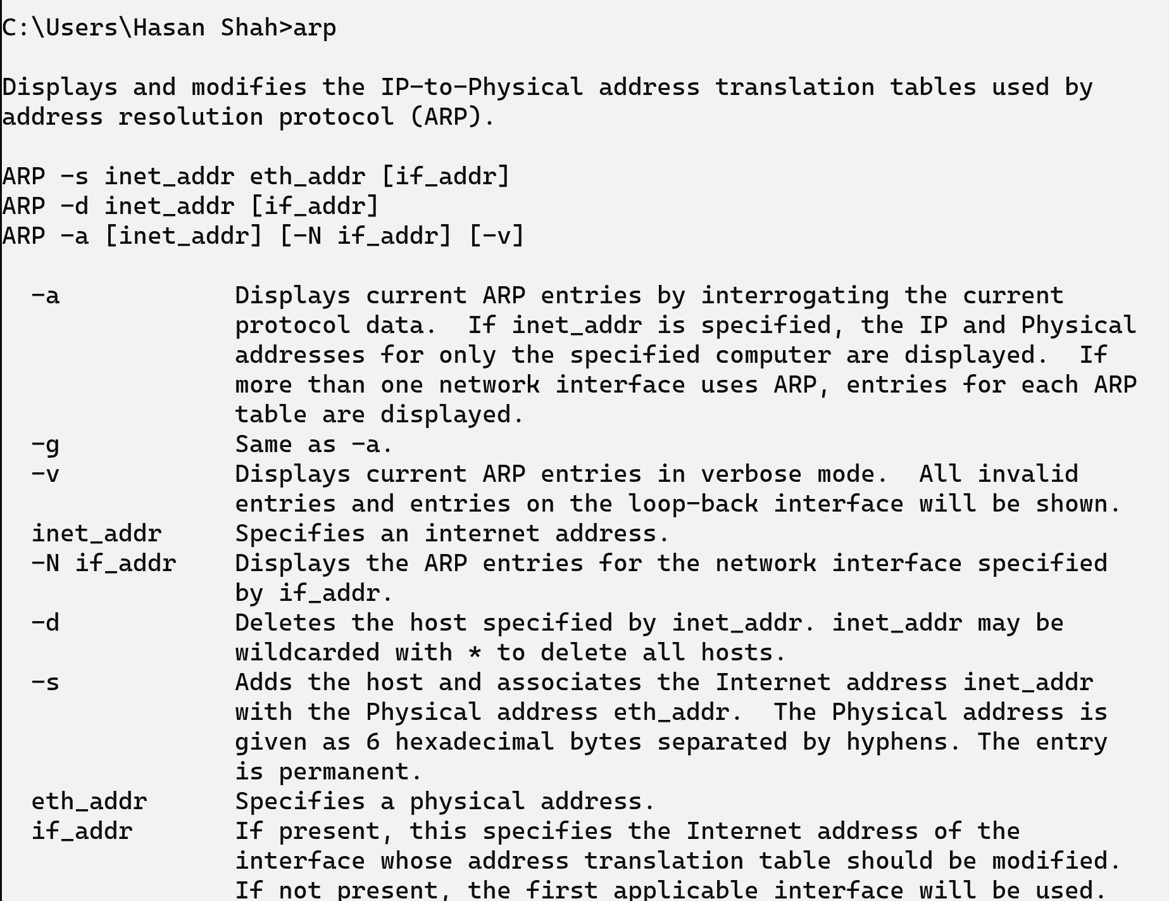

You can display the complete ARP cache by running the following command:
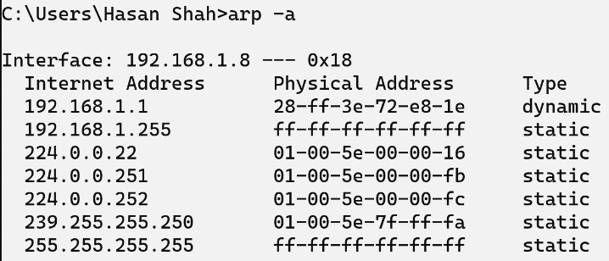
arp -a

You should see the following output:

You can also find the ARP cache entry for a specific IP address by specifying the IP address with the arp command:

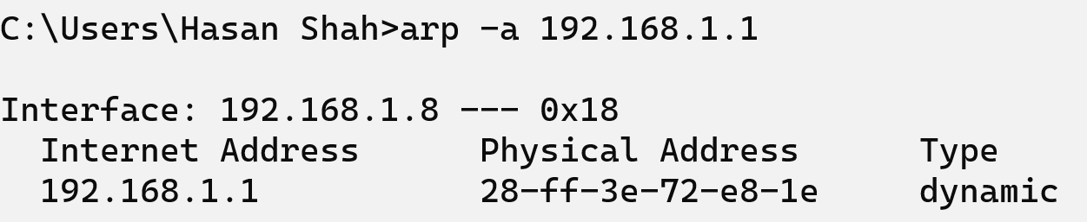
Lab Task
- Test the NIC of the PC - Ping 127.0.0.1 called (Loopback address)
- Ping the default gateway.
- Ping your hostname.
- Ping the DNS server(s)
Do you get a positive reachability result? ___________________
- How to obtain the following network configuration on your computer.
Host Name:
MAC Address:

IP Address:

Subnet Mask:

Default Gateway:

DHCP Servers:
- Open a web browser and visit the following website: http://whatismyipaddress.com/
Is the reported IP address consistent with that obtained by ipconfig? If not, why?

- Perform ARP and report dynamic addresses

- Identify the computer names of the dynamic addresses and perform ARP using computer names.

LAB 3: IP Addressing and Subnetting
Objectives
- To undersrtand IP ver 4.
- Learning the concept of subnetting.
- Study fixed length and variable length subnetting in IPV4.
- Learn about local, global, default route, loopback, and APIPA addresses.
Tools required
Advance IP subnet calculator for windows

  - Introduction to IP
The specifications of the Internet Protocol (IP) were set up by RFC791 in 1982. Some contents of the specifications stipulate the structure of IP addresses. The structure provides each host and router interface with 32-bit binary logical addresses, including the Network part and the Host part, sometimes written as N.N.N.H or represented by Subnet Mask.

For easy writing and remembering, one IP address is usually expressed by 4 decimal digits within 0~255, with a period separating each adjacent two digits. Each of these decimal digits represents 8 bits of the 32-bit address, namely the so-called octet. This is called dotted decimal notation, as shown in Figure 3.1.
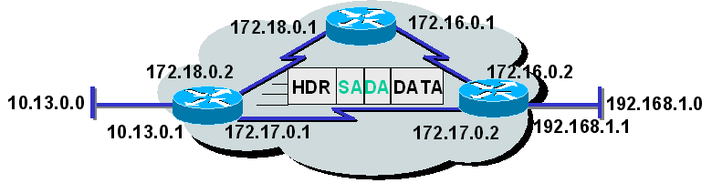
Fig. 3.1 IP Addresses
  - Classification of IP Addresses
The address types are classified according to network scale, shown as following allows:

Class A: super-large networks
Class B: medium-size networks of the limited number
Class C: a small-size network of a large number
Class D Special class: (for multi-point transmission) and
Class E, usually for test and research purposes

Types of IP addresses can be determined by way of checking the first octet in the address (the most important). The highest bit value determines the type of address. The bit format also defines the decimal value range of the octet related to each address type.

Class A:
For class A addresses, 8 bits are assigned to the network address, and the other 24 bits are assigned to the host address, represented as N.H.H.H. If the most significant bit of the first octet is 0, the address is a class A address.

This corresponds to the possible octet of 0~127. Among these addresses, 0 and 127 are reserved, so the actual value range is 1~126. Among type A addresses, only 126 networks can be used. Since only 8 bits are reserved for the network address, the first bit must be 0. However, the digits for a host can be 24 bits, so, each network can support up to 16,777,214 hosts.
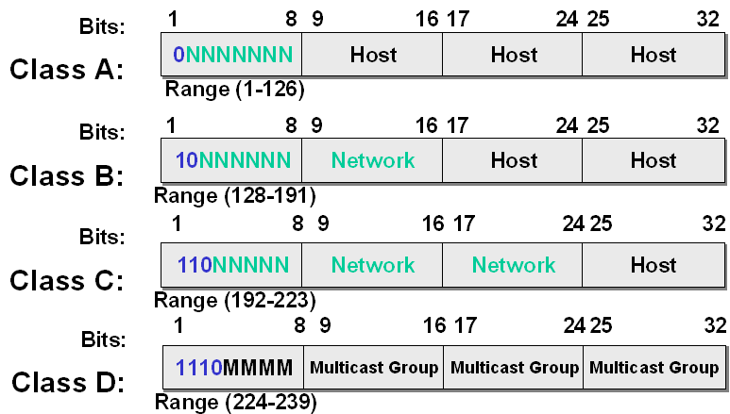
Fig. 3.2 IP Address Types
Class B:
Of class B addresses, 16 bits are assigned to the network address, and the other 16 bits are assigned to the host address. A type B address can be identified using the first two bits (set to 10) of the first octet represented as N.N.H.H. This corresponds to values of 128~191. Since the first two bits have been pre-defined, actually 14 bits are reserved for the network address. Therefore, the possible combination generates 16,384 networks, whereas each network supports 65,534 hosts.

Class C:
Of class C addresses, 24 bits are assigned to the network address, and the other 8 bits are reserved for the host address represented as N.N.N.H. In class C address, the first three bits of the first octet are 110. This corresponds to decimal digits 192~223. Among class C addresses, only the last octet is used for the host addresses. This imposes a limit that each network can have 254 hosts at the maximum. Now that 21 bits can be used as a network number (3 bits have been preset as 110), there can be 2,097,152 possible networks.

Class D:
A class D address starts at 1110. This means that the octet is within 224~239. These addresses are not used as standard IP addresses. On the contrary, class D addresses refer to a group of hosts, which are registered as multi-point transmission group members. The assignment list of the multi-point transmission group is similar to that of emails. You can use names in an assignment list to send a message to a user group. You are also able to send data to some hosts by way of multi-point transmission addresses. Multi-point transmission needs to be configured with special routes. It will not be transferred by default.

Class E:
If the first four bits of the first octet are set as 1111, the address is a class E address. These addresses are within the range of 240~254; addresses of this type are not used as common IP addresses. Addresses of this type are sometimes used in laboratories or for research.

We focus on types A, B, and C in our discussion, for they are used for conventional IP addressing.

  - Reserved IP Address
An IP address is used to identify a unique network device. However, not all IP addresses can be used. Some special IP addresses are used for various purposes, instead of identifying network devices.

An IP address with “0” exclusively for the whole host bits is called a network address. A network address is used for identifying a network segment. For example, class A address 1.0.0.0, private addresses 10.0.0.0, and 192.168.1.0 are network addresses.

An IP address with all 1’s exclusively for the whole host bits is called a network segment broadcast address. A network segment broadcast address is used to identify all the hosts of a network, for example, 10.255.255.255, 192.168.1.255, and so on. A router can transfer broadcast packets on network segments as 10.0.0.0 or 192.168.1.0. A broadcast address is used for transmitting packets to all nodes of the local network segment.

An IP address with “127” for the network part, such as 127.0.0.1, is usually for loopback tests. it is usually used to test the NIC of the system is working or not.

An IP address with the value “0” configured for all bits, such as 0.0.0.0, represents all the hosts. On a router, address 0.0.0.0 is used for designating the default route.

An IP address with the value “1” configured for al bits, such as 255.255.255.255, is also a broadcast address. The address 255.255.255.255 represents all the hosts, which are used for transmitting packets to all nodes of the network. A Broadcast like this cannot be transferred by a router.

Automatic Private IP Addressing (APIPA) is a feature in operating systems (such as Windows) that enables computers to automatically self-configure an IP address and subnet mask when their DHCP server isn’t reachable. The IP address range for APIPA is 169.254.0.1-169.254.255.254, with the subnet mask of 255.255.0.0.
When a DHCP client boots up, it looks for a DHCP server to obtain network parameters. If the client can’t communicate with the DHCP server, it uses APIPA to configure itself with an IP address from the APIPA range. This way, the host will still be able to communicate with other hosts on the local network segment that is also configured for APIPA.

  - Calculation of Usable Host Addresses
As mentioned above, there may be some IP addresses in each network segment that cannot be used as IP addresses for hosts. Now, let’s calculate the available IP addresses.
In class B network segment 172.16.0.0, there are 16 host bits, so there can be 2¹⁶ IP addresses accordingly. With one network address 172.16.0.0 and one broadcast address 172.16.255.255 deducted (they cannot identify a host), there will be 2¹⁶-2 addresses available for hosts.
In type C network segment 1192.168.1.0, there are 8 host bits, so there can be 2⁸(256) IP addresses; with one network address 192.168.1.0 and one broadcast address 192.168.1.255 deducted, there will be 254 addresses available for hosts. We can calculate the addresses available for hosts in each network segment with the following method: If there are n bits for hosts in the network segment, the number of addresses available for hosts will be: 2n-2.
A network layer device (such as a router) uses a network address to represent the hosts in the network segment, thus greatly reducing entries of the routing table of the router.
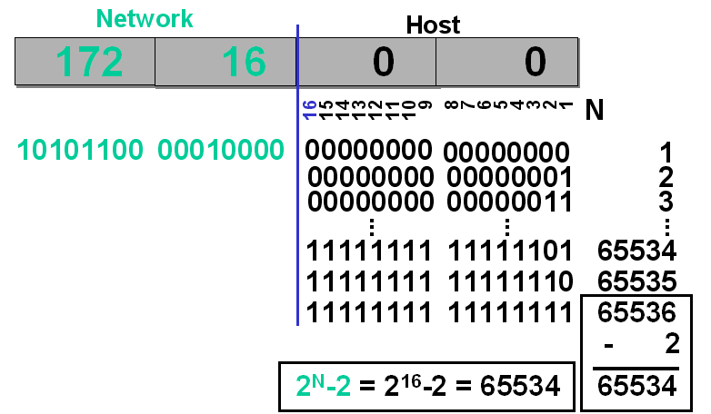
Fig. 3.3 Calculation of Number of Available Host Addresses

  - Addresses with Subnet Division
Any IP address organization without a subnet will be considered a single network. It is not necessary to know its internal architecture. For instance, all routes to address 172.16.X.X are considered as in the same direction, so the third and fourth octets of the address will not be taken into consideration. A plan like this can have fewer entries in the routing table.
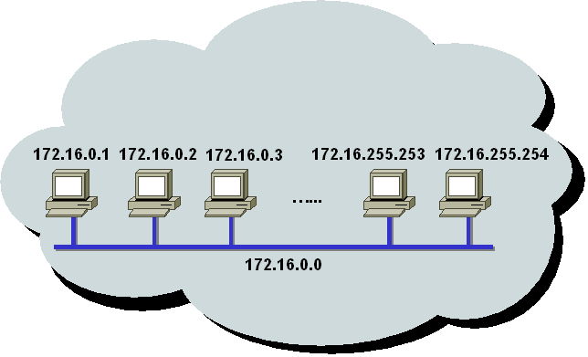
Fig. 3.4 Addressing without Subnet

However, this plan is unable to distinguish different subnet segments in a large network. In this case, all the hosts in the network receive the broadcast in the large network. Therefore, it will reduce the network performance, and hinder network management.
For example, a class B network can accommodate 65000 hosts, but it is too difficult to manage so many hosts simultaneously. So we need to divide such a network into different segments. In this way, we can manage the subnet according to network segments. Usually, host bits can be divided into subnet bits and host bits.
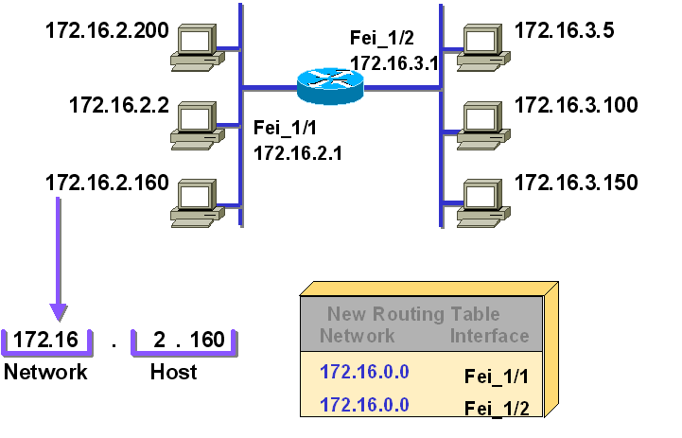
Fig. 3.5 Addressing with Subnets

In this example, the subnet bits occupy the 8 bits of the third segment. Compared with the previous example, the original class B network is divided into 256 subnets, and the number of hosts each subnet can accommodate is reduced to 254.

When different subnets are divided, different logical networks are created accordingly. The routers are responsible for communication between these different networks. That is, an original large broadcast domain is divided into multiple smaller broadcast domains.
A network device uses a subnet mask to identify network bits, subnet bits, and host bits. The network device can distinguish the destination address of an IP packet, according to the IP address and subnet mask configured. The network device can distinguish whether the destination address of an IP packet and its address are located in the same subnet, in a network of the same type but in different subnets, or in networks of different types.

  - Subnet Mask
An IP address without the related subnet mask is of no significance.
A subnet mask defines how many bits from the 32 bits of an IP address are used as the network bits, or as bits for the network and its related subnet bits.
Fig. 3.6 Subnet Mask

The binary bits in the subnet mask can be used as a filter, which calculates the network address by identifying the part of the IP address of the network address. The process of this task is called “Bitwise AND”.

“Bitwise AND” is a logical operation, which performs the calculation of each bit of the address and the corresponding mask bit.

To divide a subnet is actually to borrow the host bits in the original address to be used as the subnet bits. It is currently stipulated that bits shall be borrowed from the left to the right in succession, that is, the 1 and 0 in the subnet mask shall be consecutive.

  - Examples of Address Calculation
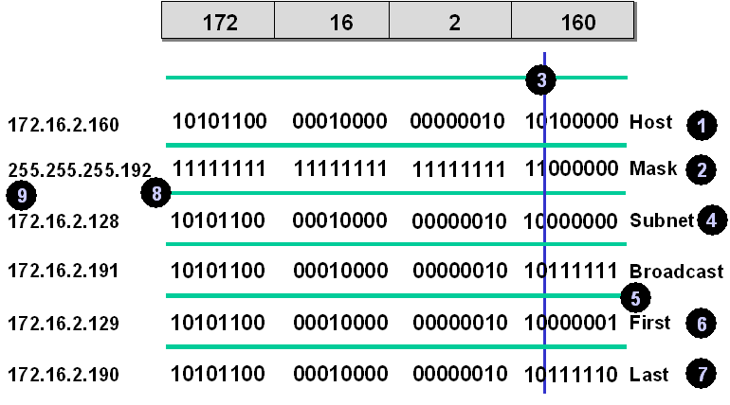
Fig. 3.7 Examples of Address Calculation

Above are examples of address calculation:

For a given IP address and subnet mask, the address calculation involves the address, the broadcast address, and the available IP address range of the subnet where the IP address is located.
• Convert the IP address to one presented in the binary system.
• Also convert the subnet mask to one presented in the binary system.
• Draw a vertical line between 1’s and 0’s of the subnet mask. Bits on the left side of the line are for the network (including the subnet), and bits on the right are for the host.
• Set all the host bits as 0. The network bits are the network address of the subnet.
• Set all the host bits as 1. The network bits are the broadcast address of the subnet.
• The available IP addresses range from the network address to the broadcast address of the subnet.
• Complete the above three network addresses.
• Finally, convert them to decimal numbers.

IP Addressing & Network Planning

Subnet Mask Task (Rough work at the back of the Page)

Solved Example

IP Address Subnet Mask Class Network address Of given IP Broadcast address of given IP
C | 203.200.10.56 | 203.200.10.63
203.200.10.60 255.255.255.248

First Subnet _203.200.10.0___ No. of Hosts per subnet ____6____

Class 1st subnet of Network 1st subnet Broadcast address

13.14.193.6 255.255.248.0
This IP Subnet_________________ No. of Hosts per subnet ________

Class Network address Of given IP Broadcast address of given IP
128.17.35.13/30 _____._____._____._____

First Subnet_________________ 2nd subnet address ______________ No. of Hosts per subnet __________

Class Network address Of given IP Broadcast address of given IP

145.60.6.27/25 _____._____._____._____
First Subnet_________________ last Subnet address ______________ No. of Hosts per subnet __________
Network address = keeping all the bits of a host as “0”, Broadcast address = one address before next subnet & No. of Hosts = 2^{n}-2 (n= No. of bits)

LAB 4: Configuring Basic Switch and Router

Objectives
- Perform basic switch configuration on zero configured Switch in Cisco packet tracer to enable the Switch for the basic functionality.
- Complete walk-through of 100 MB full duplex configuration in Cisco Switch step by step.

- Introduction
There are a lot of devices that fall into the “network switch” category. Since we’re talking about configuration, we’ll be referring specifically to managed switches in this article. It’s worth noting how you configure a Layer 2 vs Layer 3 switch will be different, as will small office/home office (SOHO) vs. enterprise switches. And don’t forget there are always going to be small differences between vendors and software versions.

Because Cisco is so common, and its IOS-style CLI is used on more than just Cisco switches, we’ll focus on the command-line configuration of Cisco switches running IOS as our prime example. But you’ll be able to use what we cover here in lots of different environments. Because many of the commands and concepts apply to routing devices too, this can also be a good reference for basic router and switch configuration.

From a network perspective, we’ll focus on features related to Layer 2 switching.

A good thing about the Cisco IOS is that it works quite similarly on both the routers as well as switches, However, there is a difference in the commands that we use for each one of them. For example, some specific commands are meant only for the switches while others are for routers as per the device's functionality.

In this lab, we will assign an IP address to the VLan1 interface and we will configure the default gateway on the Switch. We will also perform some basic configurations which will prepare the Router for the functional network.

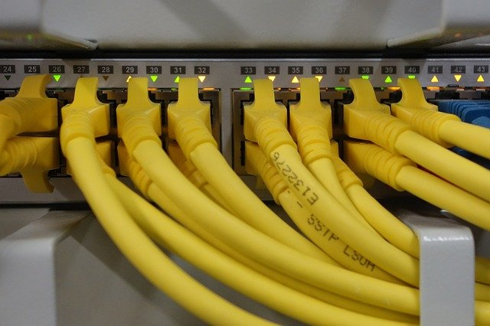
Figure 4. 1 Ethernet cables connected to the Switch

- Basic Switch configuration:
Basic switch configuration can be thought of as the minimum network, port, and security provisioning required for the production deployment of a switch. In practice, your exact needs will vary from environment to environment. And overall, effective switch management is a detailed topic in its own right.

Our goal here is to cover some switch and router configurations basics that apply to most production use cases. These include configuring device management settings and hardening the switch and router.

All switches come with default VLAN1, To assign an IP address to the VLAN1 interface, we have to enter interface configuration mode. While configuring the Switch for basic functionality, we should also assign a default gateway to the Switch.

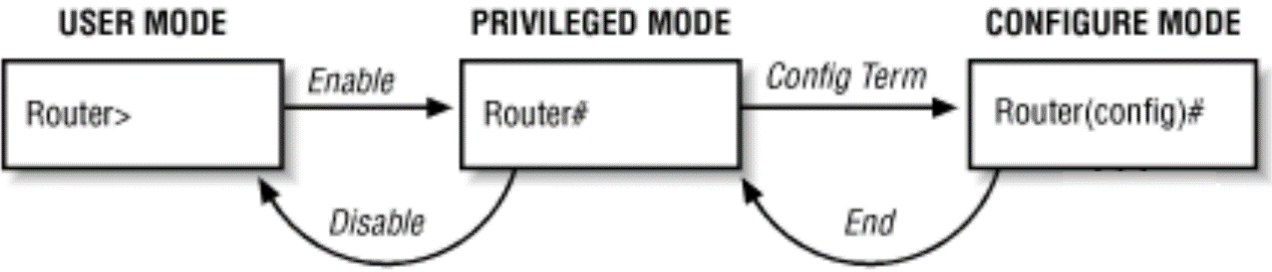
Figure 4.2 modes of switch and Router

It is important to remember that the VLAN1 interface and default gateway IP address must be on the same network. This enables the Switch to redirect traffic to other networks.

Routers however are considered gateways and do not support VLANS. Routers have limited interfaces and each interface requires a different Network address.

  - important Commands To Remember
Before we proceed some commands require your attention. They are helpful while you perform actions on the switches.

    - Saving the configurations on Switch
Vlan1 interface allows us to connect with the Switch remotely via telnet, we can use the telnet client to remotely manage and configure the Switch. If you are unable to save the changes made to the Switch, all the hard work will do down the drain. Therefore, if the changes made to the Switch is worth-a-while and nothing unexpected has occurred, the user may save configuration on Cisco devices by typing the command 'write'. It copies the running-config to the startup-config alternatively we can also use the command 'copy running-config startup config' to save the running configuration of the device.

    - No IP Domain Lookup
While configuring Cisco devices, it's common to make typing mistakes. If we mistype a command then the Cisco device will try to resolve the name to the IP address. This makes Cisco devices freeze for about 60 seconds as it resolves IP addresses in the background. One minute is the maximum time taken by the device. Now, we have to wait until the device allows us to type something again. This can be very annoying. It happens because the domain name lookup is enabled by default in Cisco devices. Hence, to solve this problem we can disable domain lookup by entering the command 'No IP Domain Lookup' in the switch command line.

    - Logging synchronous
Now, let us talk about the status of messages received on Cisco devices. When we receive status messages on Cisco devices the message kind of mixes with the text that we type on the CLI. This can also be very confusing sometimes.

So, to solve this problem we can type the command 'logging synchronous'. This command synchronizes the status messages. Hence, the message does not interfere with our typing.

  - Getting started
There are a lot of nuances related to the configuration of a switch that isn’t obvious to beginners. Here are some basic tips to be aware of before you start.
Command line completion, Use the tab key, and up/down arrows are time savers
Typos are a pain, and typing out long commands is tedious. Fortunately, Cisco’s IOS has features that can help you avoid typos and work faster:
a. Command Line completion. Once you type enough of a command that is unique, you can just hit enter. For example, instead of typing “configure terminal”, you can use the command “config t” like this:
Switch#config t
b. Tab completion. Hitting the tab key once you have enough unique text on the screen will auto-complete a command. For example, hitting tab after “conf” auto-completes to “configure”:
c. Command scrolling with up/down keys. Need to rerun a command? You can scroll through your command history with the up/down arrows on your keyboard.
d. Bonus! Use “?” for added help. Hitting “?” at the beginning of a command prompt will show you all the commands that are available in the current context. Hitting “?” after a command will show you all the parameters that are available in that context.
    - Access levels and modes
There are several Cisco access levels and modes that allow you to run different commands. You can learn more about each mode in the Cisco IOS command hierarchy, but the table below is a reference for our examples.
Cisco Mode | What the prompt  looks like for switch and router | Command to enter  from upper-level  mode | Command to exit  to upper-level  mode
User EXEC mode | Switch>, Router> | Default mode | logout or exit
Privileged EXEC  (access from EXEC) | Switch#, Router# | enable | disable
Global configuration  (access from  Privileged EXEC) | Switch(Config)#, Router(Config)# | config t | CTRL/Z
Interface configuration  (access from global  configuration) | Switch(config-if)#  Router(config-if)# | interface  <interface name> | Exit
Routing engine level within configuration mode | Router(config-router)# | Router <protocol>  RIP | exit
Line level configuration  (access from global  configuration) | Switch(config-line)#  Router(config-line)# | line <line name/  number>  vty, tty, aux, console | Exit

    - Console ports and cables
When you’re connecting to a switch for the first time, you’re often doing it through the console port. Usually, this is done by connecting a serial cable to the switch. You can also use a USB to serial adapter to make the connection.
Once the physical connections are made, how can you access the CLI? By using a terminal emulator. For Windows, there are several popular emulator options, like Putty, RealTerm, and TerraTerm.
    - Startup config vs. running-config
Your switch has two “config” types and locations. A switch’s running-config is stored in RAM. Its startup-config is stored in nonvolatile memory (harddisk).
Why is this important? Take it from someone who has made the mistake too many times: if your configuration changes aren’t saved to the startup-config, you’ll lose them, when the switch reboots. As you make changes to the running config, you’ll see them take effect in real-time. However, you need to explicitly save those changes to the running config for them to persist. Save yourself some pain and double-check before moving on.
Duplexing and Link Speed
Most of the time Cisco auto-negotiation for duplex selection works perfectly. However, in some instances, a Cisco device is unable to detect the duplex mode and it may result in a duplex mismatch. This could result in collisions in the network. Therefore, to fully utilize the bandwidth and the capacity of the Switch, it is a good practice to hard-code the speed and duplex on the Cisco devices.
In this lab, we will learn how to configure a basic switch and how can we connect it with LAN to communicate between the terminals. First, we will learn how to enter the command line of the switch using the console cable to configure the basic settings, once that set we will perform further settings like giving it an IP address, gateway address, duplex, and speed to links, we will have to go into the specific interface on which we want to hard-code the speed and duplex setting.
Please note that full-duplex configuration must be configured on each interface on which we want to hardcode the full-duplex mode.
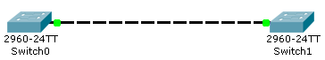
Show Commands For Switch Configurations
The following example shows how to list the show commands available in privileged mode:
Switch> enable
Switch# show <command>

Frequently used command are highlighted

Show commands:
-----------------------------------------------------------------------
show arp Show ARP table
show cdp Show Cisco Discovery Protocol Information
show running-config Show system configuration
show flash Show system flash information
show interface Show network interfaces
└status Duplex/speed
└Vlan <No.> VLan information
└switchport all vlan ports information
└trunk trunk information
show ip Show IP Information
show logging Show system logging information
show mac-address-t Show MAC table information
show port-security Show port information
show spantree Show spantree information
show trunk Show trunk ports
show users Show active Admin sessions
show version Show version information
show vlan Show Virtual LAN information
show vtp Show VTP Information
Console> (enable)

Lab Task”

Task 1. Draw the following topologies
a. Bus Topology
b. Star Topology
c. Mest Topology

Task 2. Connect 2nd layer device to a 2nd layer devices
Task 3. Connect 2nd layer device to a 3rd layer device
Task 4. Connect PC to a PC
Lab Task: Configure A Network Switch
Now that you know the basics, we can move on to the commands. Here, we’ll walk through some of the most important basic network switch configuration tasks.
While any particular production deployment will likely require specific additional steps (e.g. for additional hardening and user management), these commands will help you hit the ground running.
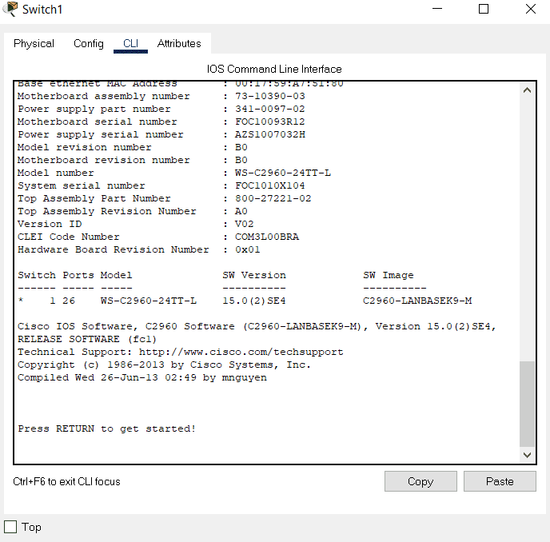
Fig 4.1 shows the start-up of a typical CISCO Switch

Task 5: Connect to the console
You need to start with a connection to the console port. That means configuring your terminal emulator software and connecting your rollover cable between your switch’s console port and your PC.
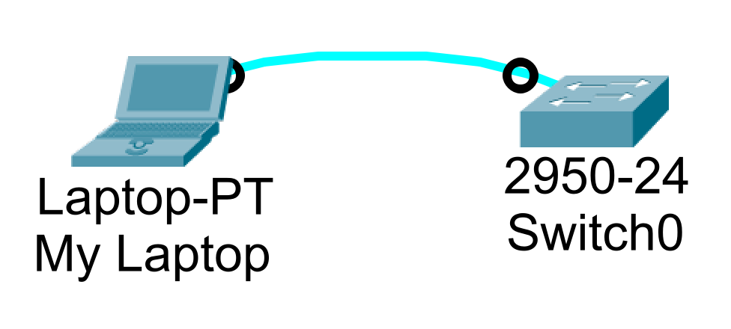
Figure 4.2 connecting a switch using a console cable
Many Cisco switches use these serial settings shown in Figure 4.3.

1. Double-click on PC0, click on the “Desktop” tab, and then click on “Terminal”.
(Note: In real life, you can use HyperTerminal or PuTTY for Windows XP.)

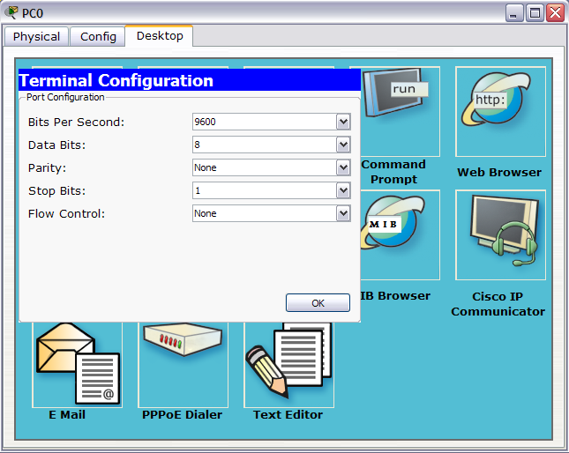
Figure 4.3 setting up the serial connection to switch

2. Set the parameters according to the above screen, and click “ok” to continue.

3. From now on, use the “Terminal” of PC0 to configure the router instead of using the CLI
in the router.

(Note: “Terminal” is how a router is configured in the real world. “CLI” shown in Figure 4.4 is just a “convenience” in Packet Tracer. “CLI” does not exist in the real world”.)

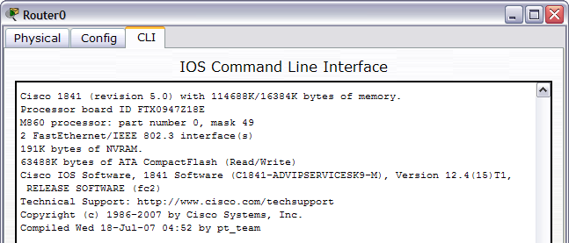
Figure 4.4 The “CLI” of the Router does not exist in the real world.

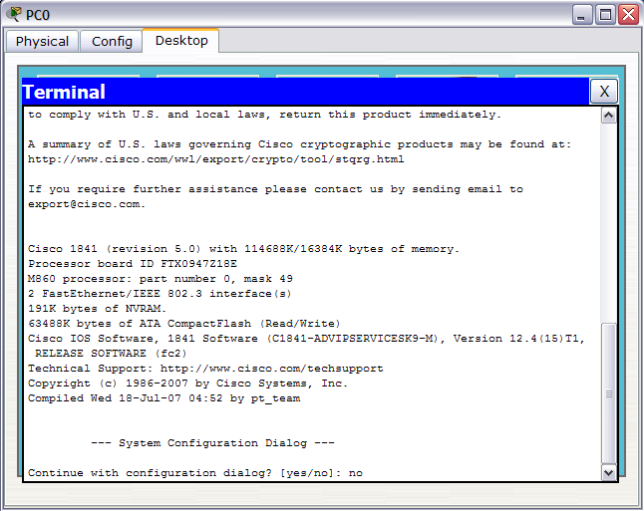
Figure 4.5 shows router configuration in the real world, with a rollover cable and a Terminal program.

- Wait for the booting up of the switch and router.
NOTE: During booting the router will ask you if you want to setup using dialog.
Type “no” (as shown in the above screen).

5. Hit enters key to get the first router prompt.

Router> OR Switch>

Task 6: Set a management IP and default gateway
The management IP address is where you can log in to the switch for future administrative tasks. Once your management IP is set up, you can use it to SSH into the switch and configure it over the network.
First, we access Privileged EXEC mode with the “enable” switch configuration command:
Switch>enable
Switch#

And
Router> enable
Router#

Assign Ip To A Switch To Use In the LAN
From there, we enter Global Configuration mode with “config t” (or “configure terminal”):
Switch#config t
[Enter configuration commands, one per line. End with “CNTL/Z”.]
Switch(config)#

Next, we access the switch VLAN interface:
Switch(config)#interface vlan 1
Switch(config-if)#no sh
Now, we can assign the management IP and subnet.
In this example, I’ll assign a 192.168.1.0 network address with a 255.255.255.0 subnet.
Be sure to replace that with the correct values for your switch!
Switch(config-if)#ip address 192.168.1.10 255.255.255.0
Switch(config-if)#

We can exit interface configuration mode and assign a default gateway for the switch from global configuration mode.

Switch(config-if)#exit
Switch(config)#ip default-gateway 192.168.1.1
Switch(config)#

Tasks For Router

Unlike the switch, we assign an IP address to each interface on a router.
For the router select an appropriate interface to assign IP, as the example shows IP address is assigned to an interface.
Router(config)# interface FastEthernet 0/1
Router(config-if)# ip address 192.168.1.1 255.255.255.0
Router(config-if)# no shutdown (as the interfaces are shut, use the command to turn them on
Router(config-if)# exit

Task 7: Set hostname
In addition to setting the IP address of the switch, you should give it a logical hostname. To do that, we enter global configuration mode and use the hostname command:
Switch(config)#hostname <ROLL NO.>+ <SWITCH No.>
PepperAndEggSwitch(config)#

Task 8: Setting Duplex of Individual Port
Switch(config)#interface FastEthernet 0/1
Switch(config)#duplex full

Task 9: Setting speed of individual port and setting up the mode
Switch(config)#interface fastethernet 0/1
Switch(config)#speed 100
for switch port to set up as ACCESS or TRUNK (switch-switch)
Switch(config-if)#switchport mode access OR trunk

Task 10: For multiple ports assignment (only for Switch)
Apply the above on all ports of Switch, How Use range command

switch(config)#interface range fastethernet 1/24
switch(config-if-range)#
OR
switch(config)#interf r f1/1-24
switch(config-if-range)#

Task 11:Save Configuration
When our configuration is complete, we can save our changes to the startup configuration. Don’t forget this step, or all your work will be gone come the next switch reboot!

Switch(config-if)#exit
Switch(config)#exit
Switch#
%SYS-5-CONFIG_I: Configured from console by console

Switch#copy running-config startup-config
Destination filename [startup-config]?
Building configuration...
[OK]

OR
Switch#write

Task 12:
Switch(config)#no ip domain lookup
Router(config)#no ip domain lookup

Task 13:
Switch(config)#line con 0
Switch(config-line)#logging synchronous

Router(config)#line con 0
Router(config-line)#logging synchronous

Task 14: Show running-config
Switch# show run

LAB 5: Securing the Switch and Router

Objectives
- Configuring MOTD banner and Telnet in packet tracer.
- Learn about telnet configuration in Cisco packet tracer.
- We will encrypt various passwords configured on the Cisco device using commands.
- we will be configuring switch port security in the packet tracer to secure the Switch from unauthorized access.
- We will also learn how to limit the MAC address to connect to the switch port.

- Introduction
This lab exercise entails the basic setup of the Switch or a router. In this lab, we will configure the IP address on a fast Ethernet port of the Router. We will name the interface the 'Branch Office Interface.' Naming the interface is an excellent and very essential practice because it will let us know, to which location the port is connected.
As a Network Admin, when we log into a router, the description of the interfaces is very helpful. It makes management of the interfaces a wee bit easier, especially in big networks where there are many different devices. The user has to go into the interface configuration mode to set up the IP Address and description.

  - MOTD banner and Telnet
You will also learn to configure MOTD [Message of the Day in this lab. When the user is logged into the device then a message appears on the screen. That message is known as the Message of the Day (MOTD). Usually, the MOTD banner is set up as a warning against unauthorized access.
Some people show ASCII art and huge messages like terms and conditions as a message of the day however best practice is to use short and precise MOTD banners as big messages put extra load on the device which results in unnecessary processor cycles.
It's all up to the admin to choose whatever message of the day should show up when we log in to the Cisco device.

- The message of the Day (MOTD): This type of login message has been around for a long time on Unix and mainframe systems. The idea of the message is to display a temporary notice to users, such as issues with system availability.
However, because the message displays when a user connects to the device before login, most network administrators are now using it to display legal notices regarding access to the switch, such as unauthorized access to this device is prohibited and violators will be prosecuted to the full extent of the law and other such cheery endearments.
- Login: This banner is displayed before login to the system, but after the MOTD banner is displayed. Typically, this banner is used to display a permanent message to the users.
- Exec: This banner displays after the login is complete when the connecting user enters User EXEC mode. Whereas all users who attempt to connect to the switch see the other banners, only users who successfully log on to the switch see this banner, which can be used to post reminders to your network administrators.

  - Telnet connection and Testing
Configuring the Telnet Connection on the Router allows the user to manage the Router remotely with the help of a Telnet Protocol. Setting up a Telnet Connection also requires a Telnet Password to be configured. We will configure that password in this lab. Also, we will have to get into the Telnet lines to configure the telnet. We can do this by typing the line VTY command.
Configuration of the telnet helps a lot when we have to manage the device from a remote location or we are not available onsite. Configuration of the devices remotely has become common practice now a day and especially due to the Coronavirus outbreak, most IT individuals are working from home using the internet.

Using the internet is not to connect to an office network is not safe and secure so to overcome this issue we should use a VPN connection or we should use SSH instead of telnet as it encrypts the data which prevents the network from attacks from hackers.
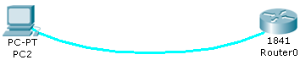
Fig 5.1 Telnet configuration in Cisco packet tracer.

    - Description:
Telnet -Protocol developed in 1969, allow us to connect to the remote device using the command line interface, telnet protocol is part of the TCP/IP suite. To use the telnet, the device should have a telnet client installed and the remote device should be configured to accept telnet connection so most of the devices like servers, routers, switches, firewalls, etc are configured to allow telnet connection.
We can use any telnet client to establish the connection; one of the famous free telnet clients is putty. Putty is used by many organizations as it is open source and it also works for SSH connection.
In this packet tracer lab, we will set up a router for telnet access. And then use the command prompt on the computer to test our telnet connection. To telnet the Router from our PC we will have to assign an IP address to our PC. After that, we will assign the IP address to the router interface which is connected to that PC.
For establishing a successful telnet connection, our PC and Router should be on the same network as the PC and Router are connected directly.
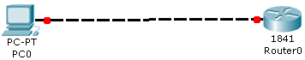
After assigning the IP addresses to both our devices, we have to enable the Router for a telnet connection by configuring the VTY lines. We will configure telnet lines 0-15 on the Router, which will allow 16 simultaneous telnet connections to the Router, this feature is helpful if more than one person wants to log in to the device at the same time, this type of practice is common if we have many administrators to look after the device.
Once we have configured both devices properly, we can try pinging the Router from our PC to check the connectivity. If the Router is responding to the ping command then we can establish a telnet connection from our PC's command prompt. Once the telnet connection is initiated successfully, we will be prompted with the password to access the Router via a telnet connection.
An important thing, we have to configure the privileged mode password. That's because it is not possible to access the privileged mode through a telnet connection if the password for our privileged mode is not configured. if we will try to access privileged mode without the configuration of the password then we will see an error message saying 'no password set'.
  - Cisco Password Encryption.
Configuring passwords and securing devices is very important and we must configure the password on different layers to prevent unauthorized access to the device.
Due to the increased number of cyber-attacks, networks now a day are more prone to online attacks rather than physical damage to the devices and hackers continuously try to find out the loophole in the network to compromise the security. Every year organizations lose thousands of dollars due to cyber-attacks and sometimes important data is lost permanently. Most of these attacks can be prevented if security is properly implemented at every layer.
There are various types of devices available in the market to stop these attacks like advance firewalls, intrusion prevention systems, antivirus, etc however we should not ignore the basic security parameters like setting up a good password on the device. Organizations spend a large amount of money on expensive hardware to secure the networks however that can be of no use if security is not implemented at every layer.
In this lab, we will encrypt all the passwords on the device with one command. When we configure passwords like Privileged Mode password, VTY line password, Console line password, etc. on our Cisco devices, these passwords are visible as clear text in the running-config. This is a security vulnerability since anyone can view them just by looking at the running-config or start-up config. Even when you are checking the Cisco device configuration, someone could be watching over your shoulder. To fix this problem, we could use a command known as the 'service password-encryption. This command encrypts all passwords and converts them into alphanumeric numbers. Hence, we can use this command to store and display the passwords in encrypted form for added security.
Service password-encryption command encrypts the password so just by looking at the password, no one will be able to figure out or steal it however it does not provide complete protection as someone can easily copy that encrypted password from the running or startup-config and can find the used password by decrypting that, there are some sites available online that easily decrypt the password with just one click so we must use enable secret that use MD5 hash to encrypt the password which is a very powerful encryption and it is not easy to reverse engineer the hash.
Although password encryption should be enabled by default it is not so we have to manually encrypt the passwords.

  - Cisco Port Security: Configuring switch port security in packet tracer.
Cisco has implemented some security measures to safeguard its devices from unauthorized access. Therefore, to be able to secure the physical ports on a Cisco Switch, we have to enable Port Security.

There are a few options available to the user while configuring the Port Security. One such option is to limit the number of MAC Addresses that the port can connect with. This security feature does not provide complete security however it makes it extremely difficult for the attacker to break into the network. The only way a hacker can beat this security parameter is by finding out the attached mac-address and giving the same mac-address to the device which attackers want to connect to the particular switch port.
Many times, some employees in the organization connect their devices to the switch port available in their cubicles just for the fun or sometimes for experimental purposes, and if security is not implemented then that device can jeopardize the whole network and hackers can also this vulnerability to hack into the network.
In this lab, we will allow only one MAC Address to be able to access the interface fast Ethernet 0/2. If some other device is attached to the interface the port will go to a shutdown state. Also, when the port will be shut down then the light on the Switch will turn amber on that switch port so the admin can find out the issue just by looking at the physical indicator on the Switch.
To enable Port Security on a Cisco switch, we have to change the switch port mode from dynamic to access. By default, the switch port mode is set to dynamic. Once the switch port mode is changed, we can then enable the switch port security on that port. There are a couple of ways in which we can restrict devices with random mac-address to connect with the switch port. One way is to hardcode the mac address on the switch interface with the command "switchport port-security mac-address [mac-address number]"
Another command that we can use is "switchport port-security mac-address sticky", this command will stick the already attached mac-address to the interface and other mac-address will be rejected so if devices with other mac-address will try to connect with the interface then the interface will simply reject the connection and we can also configure how the interface should react when the security violation takes place.

Lab Task
  - (Switch)
Task 1
Click on pc2 > click desktop tab > click on terminal > click ok
(you should be able to access a switch or a Router)
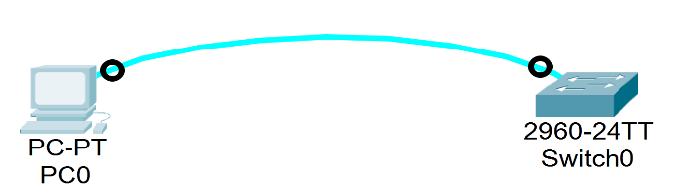

Task 2: MOTD
A banner is a message presented to a user who is using the Cisco switch. Based on the type of banner you configured for use, the message will be shown to users of the Cisco switch. Banners are a very powerful tool to alert the intruder to stay away from the device.
To configure each of these banners and set them up on your switch, follow these commands:
SW1#enable
SW1#configure terminal
Enter configuration commands, one per line. End with CNTL/Z.
SW1(config)#banner motd #Admin Access only!#
SW1(config)#

Task 3: SECURING CONSOLE AND TELNET PORTS

Set logins on VTY lines and console port (telnet connections)

Strong passwords are an important part of hardening a managed switch, so next, we’ll add a password to all virtual terminal (VTY) lines. Our switch has 16 VTY lines which are used for remote access, so we’ll configure the entire range from 0-15:
Switch(config)#line vty 0 15
Switch(config-line)#password cisco
Switch(config-line)#

Next, we’ll exit the VTY configuration, access console line 0, and assign it a separate password:
Switch(config)#line con 0
Switch(config-line)#password ciscoconsole1
Switch(config-line)#logging synchronous
Switch(config-line)#login
Switch(config-line)#history size 15
Switch(config-line)#exec-timeout 6 45

Task 4: Set Privileged EXEC password

In addition to password-protecting the VTY and console lines, we can and should protect Privileged EXEC mode with a password.

We can do that from the global configuration mode:

Switch(config-line)#exit
Switch(config)#enable secret cisco
Switch(config)#

Note: Because switch security is a complex topic, and we’re focused on the basics, we won’t go into user management here. However, be sure to properly configure users or remote authentication servers before production deployment.

Task 5: Enable SSH

At some point, you’ll find yourself in need of access to your network devices, and you’re not physically in the same room as them. To access a switch’s CLI over the network, you’ll need to use Telnet or SSH. From a security perspective, Telnet is usually a non-starter because data is transmitted in plaintext. That leaves us with SSH.

Set hostname and domain-name
Switch(config)# hostname Lab_6

Lab_6 (config)# ip domain-name Lab_6
The first step to enabling SSH is generating the RSA keys:

Lab_6 (config)#crypto key generate rsa

Choose the size of the key modulus in the range of 360 to 2048 for your General Purpose Keys.
Choosing a key modulus greater than 512 may take a few minutes.

How many bits are in the modulus [2048]:
% Generating 2048-bit RSA keys, keys will be non-exportable...[OK]

Lab_6 (config)#

Task 6 Setting SSH version to 2:
Lab_6 (config)#ip ssh version 2
*Mar 4 7:4:9.374: %SSH-5-ENABLED: SSH 1.99 has been enabled
Lab_6 (config)#

Now, we can set SSH up on specific VTY lines. I’ll use the first 6 lines here:

Lab_6 (config)#line vty 0 5
Lab_6 (config-line)#transport input ssh

Finally, we’ll tell the switch to check the local users’ database to authenticate users:

Lab_6 (config-line)#login local
Lab_6 (config-line)# username hostname password any_password

Go to the command prompt (of PC) and enter the following
ssh -L username Switch_IP

Task 7 Switch Port Access
Switch(config)#interface fastethernet 0/2
Switch(config-if)#switchport mode access
Switch(config-if)#switchport port-security
Switch(config-if)#switchport port-security mac-address sticky
Switch(config-if)#switchport port-security maximum 1

Task 8 Switch Port Security
Switch(config-if)#switchport port-security violation shutdown

  - (Router)
Task 1: connect to the Router using the console cable.
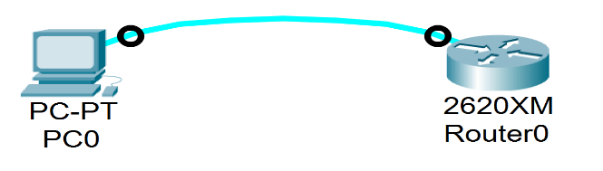
Task 2 MOTD
Router(config)#banner motd #
Enter TEXT message. End with the character '#'.
Authorized users only, violaters will be shot on sight!

Task 3 Specifies a virtual terminal for remote console access
Router(config)#line vty 0 15
Router(config-line)#password cisco
Router(config-line)#login

Router(config)# line console 0
Router(config)# password cisco1
Router(config-line)# login

Task 4
Sets the interval that the EXEC command interpreter waits until user input is detected. The default is 10 minutes. You can also optionally add seconds to the interval value.

Router(config-line)# exec-timeout 5 30

Task 5
Router(config)#interface fastEthernet 0/0
Router(config-if)#description BRANCH OFFICE INTERFACE

Task 6
Click on pc0 > click on command prompt
PC0> type telnet 192.168.1.1
PC0> type privileged mode password
Router(config)#enable secret cisco
Router(config)#service password encryption

LAB 6: Virtual LAN (VLANs)

Objectives
- Create and configure VLANs in Cisco packet tracer.
- Study the Router on a Stick Configuration.
- Learn to Configure native VLAN in Cisco packet tracer and Fix native VLAN mismatch.

- Introduction to VLANs
Technically, VLAN (virtual local area network) is also known as a virtual LAN. This technology can logically partition and isolate one or more physical LANs into multiple broadcast domains. And each broadcast domain is regarded as one VLAN. Generally, only devices under the same VLAN can communicate with each other. Why VLAN is used? Before VLAN, there was a single broadcast domain over the specified network, which is called LAN (local area work). Just like the following LAN application topology showed, to communicate with host B, host A will broadcast its ARP (address resolution protocol) request to all the switches and other hosts over the same local area network.
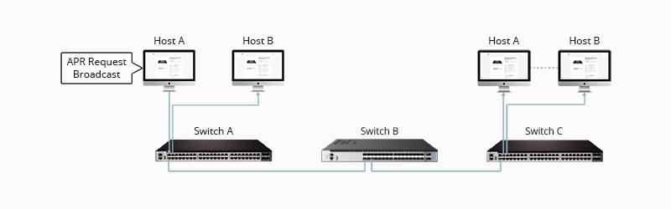
Figure 6.1 LAN overheads
- How VLAN works
Here is step by step details of how VLAN works:
- VLANs in networking are identified by a number.
- A Valid range is 1-4094. On a VLAN switch, you assign ports with the proper VLAN number.
- The switch then allows data that needs to be sent between various ports having the same VLAN.
- Since almost all networks are larger than a single switch, there should be a way to send traffic between two switches.
- One simple and easy way to do this is to assign a port on each network switch with a VLAN and run a cable between them.

- VLAN Ranges
Here are the important ranges of VLAN:
Range | Description
VLAN 0-4095 | Reserved VLAN, which cannot be seen or used.
VLAN 1: | This is a default VLAN of switches. You cannot delete or edit this VLAN, but it can be used.
VLAN 2-1001: | It is a normal VLAN range. You can create, edit, and delete it.
VLAN 1002-1005: | These ranges are CISCO defaults for token rings and FDDI. You cannot delete this VLAN.
VLAN 1006-4094: | It is an extended range of VLANs.
- Characteristics of VLAN
Here are the important characteristics of VLAN:
- Virtual LANs offer a structure for making groups of devices, even if their networks are different.
- It increases the broadcast domains possible in a LAN.
- Implementing VLANs reduces the security risks as the number of hosts which are connected to the broadcast domain decreases.
- This is performed by configuring a separate virtual LAN for only the hosts having sensitive information.
- It has a flexible networking model that groups users depending on their departments instead of network location.
- Changing hosts/users on a VLAN is relatively easy. It just needs a new port-level configuration.
- It can reduce congestion by sharing traffic as individual VLANs work as separate LANs.
- A workstation can be used with full bandwidth at each port.
- Terminal reallocations become easy.
- A VLAN can span multiple switches.
- The link of the trunk can carry traffic for multiple LANs.
- Types of VLANs
Here are the important types of VLANs
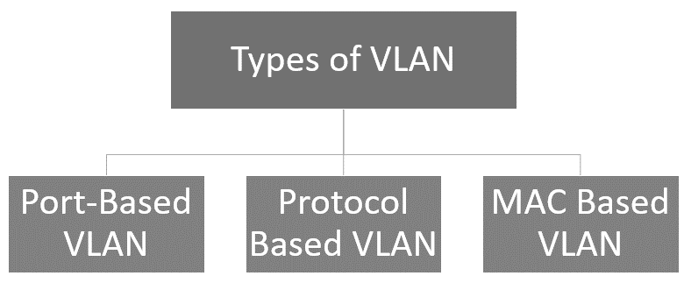
Figure 6.2 Types of VLAN
  - Port-Based VLAN
Port-based VLANs group virtual local area networks by port. In this type of virtual LAN, a switch port can be configured manually to a member of the VLAN.
Devices that are connected to this port will belong to the same broadcast domain that is because all other ports are configured with a similar VLAN number.
The challenge of this type of network is to know which ports are appropriate to each VLAN. The VLAN membership can’t be known just by looking at the physical port of a switch. You can determine it by checking the configuration information.
  - Protocol Based VLAN
This type of VLAN processes traffic based on a protocol that can be used to define filtering criteria for tags, which are untagged packets.
In this Virtual Local Area Network, the layer-3 protocol is carried by the frame to determine VLAN membership. It works in multi-protocol environments. This method is not practical in a predominately IP-based network.
  - MAC Based VLAN
MAC Based VLAN allows incoming untagged packets to be assigned virtual LAN and, thereby, classify traffic depending on the packet source address. You define a Mac address to VLAN mapping by configuring mapping the entry in MAC to the VLAN table.
This entry is specified using the source Mac address proper VLAN ID. The configurations of tables are shared among all device ports.
- Difference between LAN and VLAN
Here is an important difference between LAN and VLAN:
LAN | VLAN
LAN can be defined as a group of computer and peripheral devices that are connected in a limited area. | A VLAN can be defined as a custom network that is created from one or more local area networks.
The full form of LAN is Local Area Network | The full form of VLAN is Virtual Local Area Network.
The latency of the LAN is high. | The latency of VLAN is less.
The cost of LAN is high. | The cost of a VLAN is less.
In LAN, the network packet is advertised to each and every device. | In VLAN, the network packet is sent to only a specific broadcast domain.
It uses a ring, and FDDI (Fiber Distributed Data Interface) is a protocol. | It uses ISP and VTP as a protocol.

- Advantages of VLAN
Here are the important pros/benefits of VLAN:
- It solves a broadcast problem.
- VLAN reduces the size of broadcast domains.
- VLAN allows you to add a layer of security.
- It can make device management simple and easier.
- You can make a logical grouping of devices by function rather than location.
- It allows the creation of groups of logically connected devices that act like they are on their network.
- You can logically segment networks based on departments, project teams, or functions.
- VLAN helps to geographically structure your network to support growing companies.
- Higher performance and reduced latency.
- VLANs provide increased performance.
- Users may work on sensitive information that must not be viewed by other users.
- VLAN removes the physical boundary.
- It lets you easily segment your network.
- It helps you to enhance network security.
- You can keep hosts separated by VLAN.
- You do not require additional hardware and cabling, which helps you to save costs.
- It has operational advantages because of changing the IP subnet of the user in software.
- It reduces the number of devices for a particular network topology.
- VLAN makes managing physical devices less complex.
- Disadvantages of VLAN
Here are the important cons/ drawbacks of VLAN:
- A packet can leak from one VLAN to another.
- An injected packet may lead to a cyber-attack.
- Threats in a single system may spread a virus through a whole logical network.
- You require an additional router to control the workload in large networks.
- You can face problems in interoperability.
- A VLAN cannot forward network traffic to other VLANs.
- Application/Purpose of VLAN
Here are the important uses of VLAN:
- VLAN is used when you have 200+ devices on your LAN.
- It is helpful when you have a lot of traffic on a LAN.
- VLAN is ideal when a group of users needs more security or is being slowed down by many broadcasts.
- It is used when users are not on one broadcast domain.
- Make a single switch into multiple switches.

- Working with VLANs
We will create VLAN 10 and VLAN 20 in this lab. It is always a good practice to give names to the VLANs as this makes it easier for the admins to manage the configured VLANs. The best way to give a name is according to their role in the network e.g. if there is a VLAN that handles traffic for the voice of IP then we can give the name 'voice' to the VLAN and another way of assigning a name is according to the departments in the organization like Sales, marketing, etc.
In a case of a network outage or any issue with the VLANs, admins can easily identify the VLANs with names, which makes their work easier.

We can use the following command to create VLAN 10 and 20 and give them a name.
Switch(config)#vlan 10
Switch(config-vlan)#name Voice
Switch(config-vlan)#no shutdown

Switch(config)#vlan 20
Switch(config-vlan)#name Sales
Switch(config-vlan)#no shutdown

Once we are done creating the VLANs, we can check the created VLANs with the command

Switch#show VLAN brief

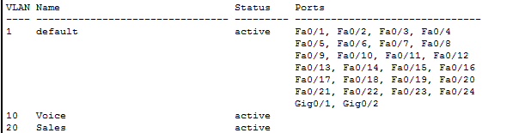

  - Assigning ports to VLANs:
You can see in the image above that although we have created the VLANs however to use those VLANs, we have to assign ports to VLAN. By default, all ports are assigned to VLAN 1
We will assign 1 port to VLAN 10 and 5 ports to VLAN 20

If we want to assign multiple ports to a single VLAN then we can use the interface range command and include the range of ports that we want to add to any VLAN

Switch(config)#interface fastEthernet 0/1
Switch(config-if)#switchport mode access
Switch(config-if)#switchport access vlan 10

RANGE
Switch(config)#interface range fastEthernet 0/2 – 6
Switch(config-if-range)#switchport mode access
Switch(config-if-range)#switchport access vlan 20

Now, we can see in the image below that assigned ports are appearing in front of VLAN 10 and 20

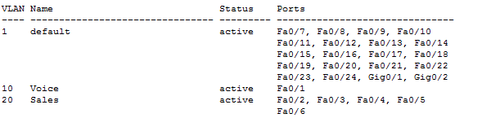

  - Inter VLAN routing in packet tracer

Each VLAN represents a separate network so to enable routing from one VLAN to another VLAN; we have to either use a layer 3 switch or Router.
On a single router interface, we can create sub-interfaces and configure those interfaces to accept traffic from specific VLANs so we can use only one interface that is connected to the Switch for routing purposes.
After configuring the sub-interfaces, we have to assign a default gateway on the end device so the default gateway would be the IP address of the sub-interface specified for the same VLAN of the end device.
Now the traffic will travel within Switch when communicating with the end device in the same VLAN and traffic will travel through the Router when communicating with devices on other VLANs.
Please check section 2 ‘router on a stick’ part to properly configure inter-VLAN routing.

- Router on A Stick:
'Router on a Stick' allows routing between VLANs with only one interface. Each VLAN represents a different Subnet. In general, routers can take traffic from only one subnet and transfer it to another subnet. And we can assign only one IP Address to a router interface. 'Router on a stick' allows us to create sub-interfaces, and assign IP Addresses to those sub-interfaces. To make it work, we have to create a truck connection between the Switch and a router so that traffic from multiple VLANs can be sent to the Router.
If we create a route between VLANs without the 'Router on a Stick' method, then we have to waste interfaces on the switches and routers. And if we enable routing between multiple VLANs then it will become practically inefficient as the switches and the routers will use those multiple interfaces.
The image below is an alternative method for allowing routing between VLANs. As you can see, we are using two interfaces on both the Router and a switch to allow routing between VLANs. We have not created a sub-interface in the below figure.
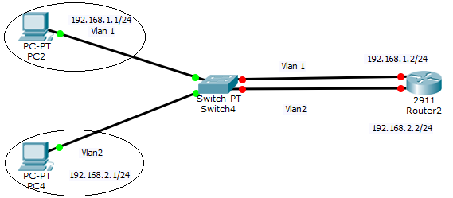
You can see that we have to use extra interfaces for each VLAN. So, it becomes practically non-efficient if we have multiple VLANs. Hence, 'Router on a Stick' is a perfect solution for routing between VLANs with just one router interface.
The simpler way to do routing between VLANs is by using a Layer 3 Switch. We just have to create virtual interfaces for each VLAN and assign them IP Addresses from the same network. A Layer 3 Switch will then enable routing between VLANs as it has routing capabilities as well. However, Layer 3 Switch is quite expensive so it might not be an affordable option for small office networks.
In the below lab, we will configure a 'Router on a Stick' that would allow routing between the VLANs. Some of the important concepts in this lab are – creating sub-interfaces, using the encapsulation dot1Q command to encapsulate the traffic, and mentioning the VLAN number to ascertain for which VLAN the sub-interface should respond.
Draw the figure on the Packet tracer, as shown below to start configuring Router on a stick configuration in the packet tracer.

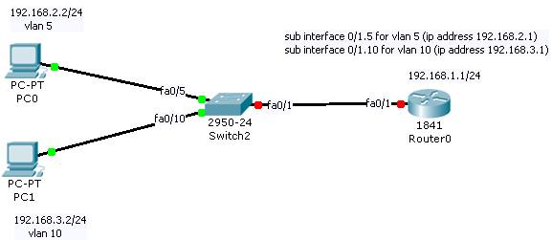
- Native VLAN and Mismatch:
Native VLAN – Native VLAN allows untagged traffic to be part of one particular VLAN. Native VLAN functionality is used when untagged traffic is received on the trunk connection of the Switch.
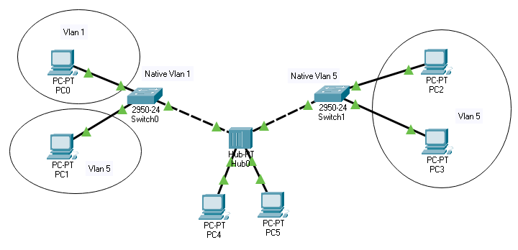
In the above image, you can see that the Hub is connected to the Switch. VLAN and tagging are switching technology and as Hub is unable to tag the traffic then what will happen if PC 4 and PC 5 which are connected to the Hub send the traffic? In that case, we have to specify native VLAN on both of the switch interfaces that are connected to Hub, and that will help when the Switch will receive the untagged traffic on those interfaces then it will be part of the specified VLAN which we have configured as Native VLAN.
Although Hubs are not in use now a day's however in a small organization where the budget is low and organizations cannot afford to spend money on new network equipment and they want to use the old network devices then network admin may have to work with such topologies.
In small networks, speed is not the priority for the company so using the device as a hub does not harm the network.
Another network scenario, in which native VLAN is used commonly, is shown below. IP phones are used commonly in companies these days, they allow daisy-chaining of end devices like PC which saves the interfaces and saves the extra cost of the telecom.
Daisy-chaining the PC is an efficient solution as an organization does not have to buy extra switches to implement IP phones.
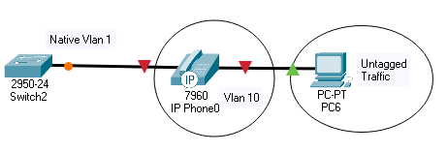
PC 6 cannot tag the traffic so we have to configure Native VLAN to route the traffic generated by the PC on the desired VLAN. However, the Cisco IP phone can tag the traffic so native VLAN will only be used by the PC.

By default, native VLAN is configured as 1 on all the interfaces however, in case we want to route traffic to another VLAN then we have to change the native VLAN accordingly.
To check the native VLAN that is configured, we can use the command 'show interfaces trunk'
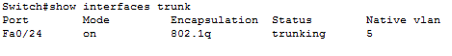
To configure the native VLAN or to change the default native VLAN, we have to use the following command.
Switch(config)#interface FastEthernet 0/24
Switch(config-if)#switchport trunk native vlan 5

We have to enter into interface configuration mode and then use the command shown above; we have to specify the VLAN number where we want to redirect untagged traffic. In the above example, traffic will be routed to VLAN 5.
  - Native VLAN mismatch
Native VLAN mismatch happens when interfaces of the Switch are configured with different native VLANs and in that case, traffic generated by the PC will be routed to both VLANs which will cause issues in the network.
The good thing about the Switch is that it detects the native VLAN itself and the following message is displayed on the Command-line interface of the device.
— %CDP-4-NATIVE_VLAN_MISMATCH: Native VLAN mismatch

discovered on FastEthernet0/24 (5), with Switch FastEthernet0/24 (1) —

To fix the Native VLAN mismatch, we have to configure the same native VLAN on all interfaces that are connected to the Hub so that the traffic generated will only be redirected to one VLAN.

In this lab, we have intentionally created a native VLAN mismatch so you can learn and practice fixing the mismatch by assigning the same Native VLAN on both switches.
You will be able to see the mismatch message on the CLIs of both of the switches.

Lab Task

Task 1
Click on pc0 > click on desktop tab > click on IP configuration > set IP address and default gateway

Task 2
Switch(config)#interface fa0/5
Try Range command for allocating multiple ports to a Vlan

Switch(config-if)#switchport access vlan 5
Switch(config-if)#in fa0/10
Switch(config-if)#switchport access vlan 10

Task3
Switch(config)#in fastethernet 0/1
Switch(config-if)#switchport mode trunk

Task 4
Router(config)#in fa 0/1
Router(config-if)#no shutdown

Router(config)#interface fastethernet 0/1.10
Router(config-subif)#encapsulation dot1Q 10
Router(config-subif)#ip address 192.168.10.1 255.255.255.0

Router(config-subif)#in fastethernet 0/1.20
Router(config-subif)#encapsulation dot1Q 20
Router(config-subif)#ip add 192.168.20.1 255.255.255.0

For Routing the data Over Router

Router(config)# ip route 192.168.10.0 255.255.255.0 GigabitEthernet0/0.10
Router(config)# ip route 192.168.20.0 255.255.255.0 GigabitEthernet0/0.20

Note: Check the router ports by using the command show run the ports may differ router to router, respectively.

LAB 7: Cisco Discovery Protocol (CDP) and Servers

Objectives
- Using CDP protocol to find out neighbour information in Cisco packet tracer.
- Setting up a DHCP server in Cisco packet tracer.
- Configure a WEB server in the Cisco packet tracer and access the internet.
- Configuring DNS server.

- Introduction: CDP Protocol:
CDP is a handy protocol. It is a fantastic tool for searching the details about directly connected devices. However, being Cisco propriety, it only works if the connected device is a Cisco device. It sends messages to the directly connected devices, these messages contain details about the host, devices, network, IOS, ports, etc. It is enabled by default on all Cisco devices.
CDP protocol generates messages every 60 seconds, these messages are received by the neighbor device and then the information is stored in the database.
CDP provides us with information that is quite useful if we do not have a complete diagram or incomplete documentation about the network.
By using CDP we can find out the following information:

- The hostname of the remote devices
- Local and remote interfaces on which the devices are connected
- Type of device and the platform
- The IP address of the connected devices
- The version of IOS running

Although CDP provides good information about the directly connected devices however it can also pose a security threat to the network as hackers can identify and gather information very easily if any device in the network is compromised so it is the best practice to use this protocol very carefully and disable this protocol on highly secure devices. For e.g, we should not send CDP messages on the interface that is connecting outside of our network.
If we do not have the Cisco device on the other end then the CDP protocol will not work. However, we can use the LLDP (Link Layer Discovery Protocol) as an alternative since it is a non-proprietary protocol so most of the vendors support this protocol. It is an industry-standard protocol with the same functionality.
In this lab, you will be required to find information about directly connected devices. To find complete information and details of all the devices, you have to use telnet because CDP can only provide information about directly connected devices. In the below lab, 'device0' does not have a direct link to all Cisco devices. And finally, we have to disable the CDP on the fast Ethernet 0/5 interface of router 5 – which is connected with the ISP router – because we do not want to pass our internal network information to the internet service provider (ISP).

Draw the diagram as shown below and perform CDP in the packet tracer.
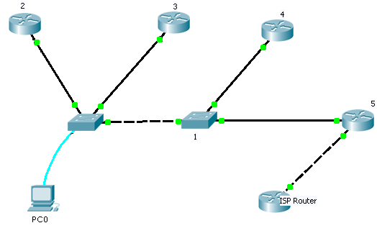

Command to see CDP information
show cdp
Use the show cdp command to display Cisco Discovery Protocol (CDP) information.
show cdp neighbors [mod_num[/port_num]] [detail]
show cdp port [mod_num[/port_num]]

Syntax Description
neighbors | Keyword used to show CDP information for all Cisco products connected to the switch.
mod_num | (Optional) Number of the module for which CDP information is displayed. If no module number is specified, CDP information for the entire switch is displayed.
port_num | (Optional) Number of the port for which CDP information is displayed.
detail | (Optional) Keyword used to show detailed information about neighboring Cisco products.
port | Keyword used to show CDP port settings.
The following example shows how to display CDP information about neighboring systems:
Console> (enable) show cdp neighbor 4
Capability Codes: R - Router, T - Trans Bridge, B - Source Route Bridge
S - Switch, H - Host, I - IGMP, r - Repeater
Port Device-ID Port-ID Platform Capability
------- ----------------------- ----------------- ------------------- ----------
4/1 001905905 4/1 WS-C5000 T S
4/1 062000101(CAT3) 9 WS-C1201 S I
4/1 069000022 8/1 WS-C5500 T S
4/1 069000040 4/2 WS-C5500 T S
Console> (enable)
The following example shows how to display detailed CDP information:
Console> (enable) show cdp neighbor 4 detail
Device-ID: 001905905
Device Addresses:
IP Address: 172.16.25.140
Holdtime: 168 sec
Capabilities: TRANSPARENT_BRIDGE SWITCH
Version:
WS-C5000 Software, Version McpSW: 2.2(4) NmpSW: 2.3(103-Eng)
Copyright (c) 1995,1996 by Cisco Systems
Platform: WS-C5000
Port-ID (Port on Device): 4/1
Port (Our Port): 4/1
___________________________________________________________________________
Device-ID: 062000101(CAT3)
Device Addresses:
IP Address: 172.16.25.212
Holdtime: 175 sec
Capabilities: SWITCH IGMP
Version:
WS-C1201 Software, Version DmpSW: 4.26 NmpSW: 4.26
Copyright (c) 1994,1995 by Cisco Systems
DMP S/W compiled on Apr 18 1997 15:03:03
NMP S/W compiled on Apr 18 1997 14:52:51
System Bootstrap Version: 1.1
Hardware Version: 3.0 Model: WS-C1201 Serial #: 062000101
1 FDDI interface
8 10BaseT interfaces
4096K bytes of DRAM memory.
1024K bytes of NMP FLASH memory.
32K bytes of non-volatile configuration memory.
Uptime is 8 days, 22 hours, 25 minutes
Platform: WS-C1201
Port-ID (Port on Device): 9
Port (Our Port): 4/1
Console> (enable)

- DHCP Server:
Setting up a DHCP server and configuring the Router as a DHCP server in the Cisco packet tracer.

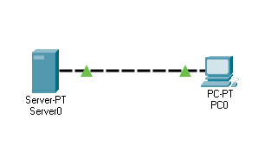
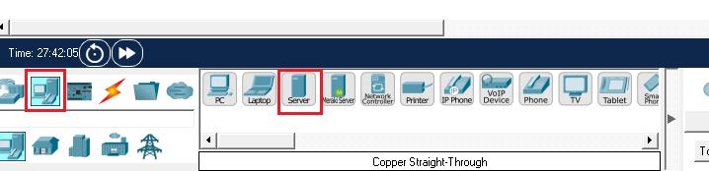

In the Cisco packet tracer, various endpoints are given that we can use to create networks and one of them is the server. This single server provides lots of services like HTTP, FTP, email, DHCP, etc.
Before enabling the DHCP service on the server, we must assign the static IP address to the server to establish connectivity.

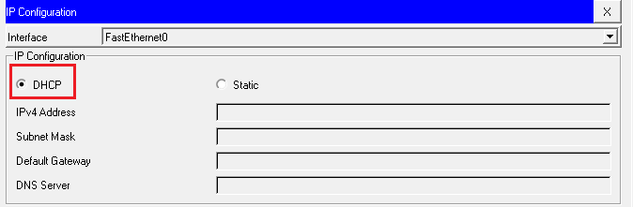

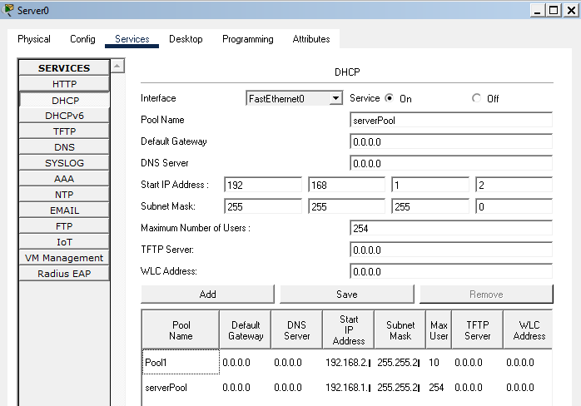

PC should be configured to accept IPs from the DHCP server so we will change the IP configuration from static to DHCP. To configure the DHCP service, we have to click on the DHCP tab and turn on the DHCP service.
We can change the default name of the pool which is server pool.
We can set up the default gateway and DNS if required as per our network design.
Define the start IP address so the server will issue the IP address according to our scope mentioned.
We now have to define the maximum number of users so the server will not lease IP addresses to the devices if the limit is reached. In this example, the defined limit is 10 in pool1, now the server will only release 10 IP addresses even if the mentioned IP range scope has a high number of IP addresses. Multiple pools can be added to the server and if any pool is not required then it can be removed easily.
One extra pool name as pool1 has been added to the server with a different IP range so now the server has a lot more IPs to assign.

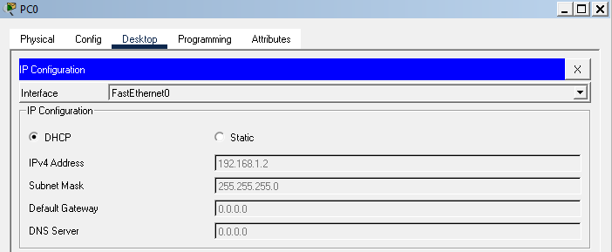

We can see in the image above that PC has been assigned an IP address successfully by the DHCP server. An assigned IP address is from the configured scope on the server.
Now, as we are done configuring the DHCP on the server. We will configure the Router as a DHCP server in the following packet tracer lab.
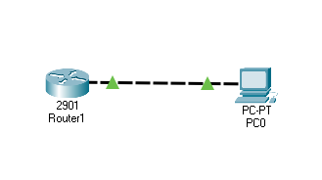
We have to configure the same parameters on the Router as well however we have to use the Router's command-line interface to set up the routers with DHCP capabilities.
We will configure DHCP on the Cisco router with 4 easy steps.
Creating a pool and naming the pool. In this lab, we have given the name 'dynamic' to the

  - DHCP pool.
Command : Router(config)#ip dhcp pool Dynamic

Defining the ranges of the addresses that the Router will lease to the clients.

Command: Router(dhcp-config)#network 192.168.1.0 255.255.255.0

Excluding the range of IP addresses that we do not want the Router to lease, this comes in handy when we want to keep some IPs that can be assigned to the devices statically whenever required in our network. In this example, we have assigned IP 192.168.1.1 to the Router so we should exclude this IP to prevent any IP address conflict.
Command: Router(config)#ip dhcp excluded-address 192.168.1.1 192.168.1.5

Finally, we will enable the DHCP service on the Router using the following command.
Command: Router(config)#service dhcp

Additionally, the time limit can be defined for the lease. For e.g, if we want the Router to lease IP for a certain period then we can configure the same using the following command.
Command: Router(config)#lease 10 10 10

This would mean that Router will lease the IP for 10 days 10 hours and 10 mins. After the defined period, the client will be given a new IP address.
OR
Use the following command to lease the IP for an indefinite time.
Command: Router(config)#lease infinite.
In the image, we can see that the PC has received the IP address from the Router so now the Router is acting as a DHCP server.

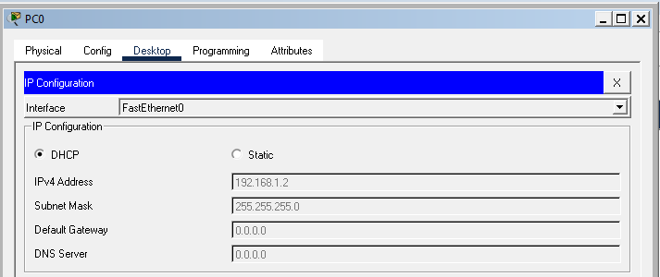
- Web Server and Internet:
To simulate the internet, we have to configure the server endpoint given. The server can provide web service.
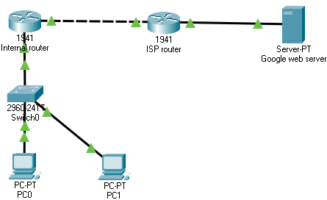
We have two hosts that will be able to access the internet via an ISP router. Our internal network is connected to the ISP router. The interface of the internal Router which is connected to the ISP router has been given public IP address. This is static IP that has been configured on the interface.
ISP router is further connected to the Google web server so after the successful configuration of our network, we should be able to access the google.com

  - How to configure the web server.
We have to open services and click on HTTP service. This service is enabled by default and we can see that server is hosting some files already. These files are present by default and when we point the web browser to this server, this server will serve the web page to our browser.

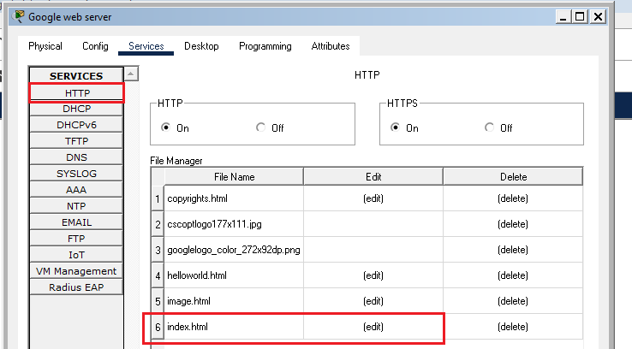

We have configured this server as a Google web server and it is serving a Google web page. To change the content of the webpage, we have to edit the index file present in the web server.
For testing purposes, we can copy the source code of any side that you want the webserver to show and paste it into the index file. After saving the file, the web server will show sites according to the source code.
Now, we can test the web server by opening the browser on the PC and pointing it to the server.

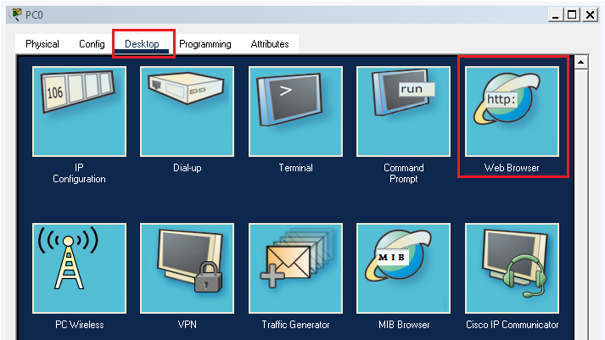

We have to enter the IP address of the web server in the URL and press enter. If everything is configured properly then we should see the browser loading the webpage successfully.

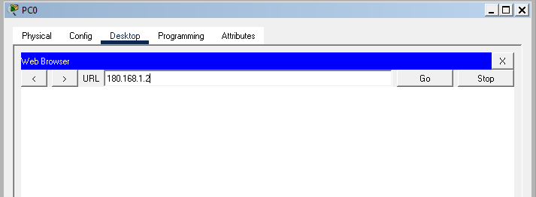

Before opening the browser, we must make sure that the connectivity of the server is fine.
Download the lab and test the Google web server and if you want the server to host any other site then change the index file present on the server.

This lab is the smaller presentation of a big network like the Internet. This is the way how the internet works however there are thousands of routers and servers connected forming a huge network.

You can try adding more servers with different sites and accessing those sites on the browser on the PC.

- DNS in Cisco packet tracer and how to configure DNS on Cisco router
There are a couple of ways in which we can configure DNS in packet tracers. We will configure DNS on the Cisco router and endpoint server.

DNS means domain name server, and DNS contains a database of domain names and IP mapping. DNS servers are very helpful as we don't have to remember the IP address and we can use the domain name instead. Names are much easier to type and learn so DNS plays an important role in every network.
When we enter google.com in the web browser the DNS server finds out the mapped IP of that domain and the HTTP request is forwarded to that IP address.
  - Configure DNS on the Cisco router
To configure the Cisco router as DNS, we have to enable the DNS service on the Router using the following command.
Router(config)#ip dns server

Now, we have to map the names with the IP address using the following command.
Router(config)#ip host PC1 192.168.1.5
Router(config)#ip host PC2 192.168.1.6

Finally, we need to configure the DNS server IP in the PC setting. In this case, as the Router is configured as a DNS server, we will use the Router's IP.

Now, we can ping one PC from another PC with their names.
Please note that Configuring the Cisco router as a DNS server is not possible in packet tracer as it does not provide this functionality however If you want to try this lab then you can use GNS3 as it has all the commands.
Configuring DNS in Cisco packet tracer with the available server endpoint

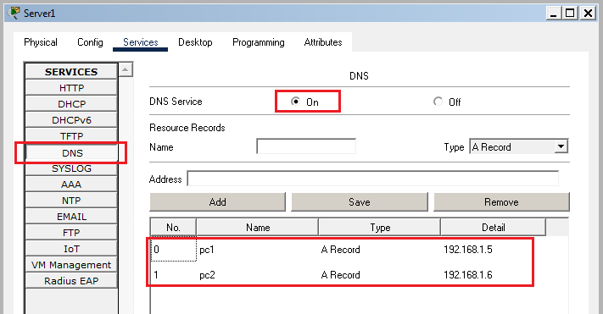
To configure the DNS server, we have to enable the DNS service in the server which is disabled by default.

Now, we have to add an A record or create a name for IP mapping in the server.
Finally, PCs should be configured with the IP address of the server in the DNS settings.

That is all required to successfully enable the DNS server in packet tracer.
Now, we should be able to ping the PCs with the names.

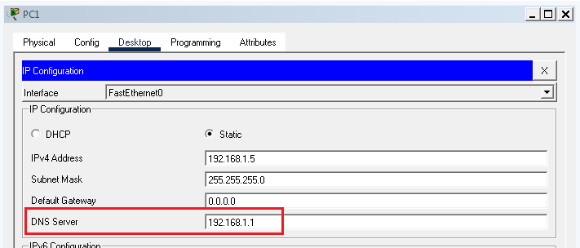
C:\>ping PC2
Pinging 192.168.1.6 with 32 bytes of data:
Reply from 192.168.1.6: bytes=32 time=35ms TTL=128
Reply from 192.168.1.6: bytes=32 time<1ms TTL=128
Reply from 192.168.1.6: bytes=32 time<1ms TTL=128
Reply from 192.168.1.6: bytes=32 time<1ms TTL=128

As expected, we can ping one PC from another with the names.
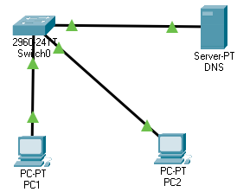
Perform this lab and ping the PC with names, and you will see the successful ping replies.
Activity for you: Create a mapping for the Switch in the server so that PCs can ping the Switch with the name 'Switch'

Lab Task
CDP
Task 1
Router#show cdp neighbors
Router#show cdp neighbors detail
Task 2
Router#no cdp run

Task 3
Router(config)#interface FastEthernet 0/1
Router(config-if)#no cdp enable

Task 4
Switch>show CDP

DHCP
Task 5
Configure the router for DHCP on the given IP addresses and connect a switch and three PCs. To obtain IP addresses from DHCP, open the IP configuration on the PC. Attach a screenshot of the PCs receiving IP addresses through DHCP.

WEB SERVER
Task 6
Add different servers to other sites and access those sites on the PC browser. Attach a screenshot of the PCs accessing these sites.

DNS
Task 7
Create a mapping for the switch in the server so that PCs can ping the switch with the name ‘switch’.

LAB 8: Open-Ended Lab

Objectives
- Apply the concepts of computer networks to design the network topology.

Create a network topology as shown in Figure 1. Configure two VLANs to segment the network, VLan 40 as “Admin” and VLan 99 as “IT”. Connect a Router with a single link to the switch and configure it for inter-VLAN routing (Router on a stick), as shown in Figure 1.
Configuration
VLAN
Assign ports 1 to 5 to VLAN 40 and ports 6 to 10 to VLAN 99 on both switches.
IP Address
The network address, i.e., the second octet of the IP addresses, is the last two digits of your roll number (the other three octets can be of your choice), e.g., 192.<Roll NO>.1.0.
Securing Switch and Router
MOTD “This Switch/Router is configured by Your Name and Roll Number”
Switch and Router security with password “labfinal”
DHCP configuration
DHCP server (IP range 200 onwards)
Testing:
(1). VLAN 40 PC to PC test (ping). (2). VLAN 40 to VLAN 99 to PC test (ping)
(3). Ping PC1 to PC2. (4). Ping PC1 to PC4. (5). Ping PC1 to router.

Note: If the last two digits of your roll number are 00, then take 100 as the second octet.

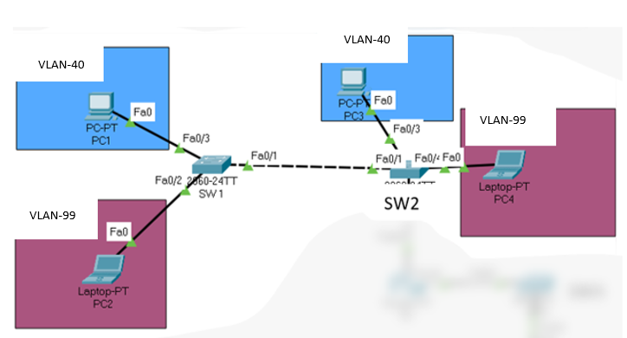
Figure 1. Network Topology for Q1

LAB 9: Switch Redundant connections and Loops (STP)

Objectives
- Study the concept of STP in packet tracer and learn to configure the STP in switches

- Introduction to Spanning tree protocol
In typical network t opology, we have redundant connections between switches. Redundant connections play a very crucial role as it eliminates the single point of failure in the network. However, redundant connections create a loop in the network. And to prevent those loops in networks the Spanning Tree Protocol chooses the best link while blocking the redundant links.
Root Bridge is the most important Switch in a Spanning Tree Network. And all the other switches choose the best way to reach a Root Bridge and block the redundant links. Therefore, it is very important to choose the best Switch in the network as a Root Bridge.
The root is selected based on a Bridge ID. So, whichever Switch will have the lowest Bridge ID, that very Switch will be selected as a Root Bridge. Bridge ID is made up of a priority number and the MAC address. And by default, all switches have the same priority number – 32768 to be precise – so the Spanning Tree relies on a MAC address for the selection of Root Bridge. But the problem is that by default any switch which has the lowest Bridge ID can be automatically selected as a Root Bridge. And if that Switch is slow then it will slow down the entire network because its network traffic will pass through that Switch. Hence, every Spanning Tree Network must have the best Switch as a root.
By default, the Spanning Tree is enabled on the switches so if we create a redundant connection on switches then the Spanning Tree Protocol will automatically come into action to prevent a loop in the network. Therefore, for maximum optimization, it is very important to select the right Switch as a Root Bridge.
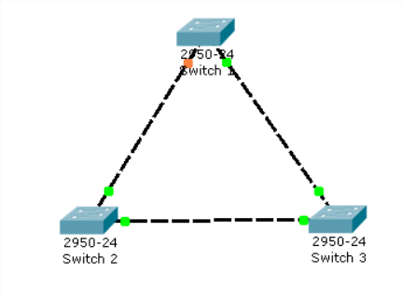
Fig 8.1 switches STP configuration
We cannot, however, change the MAC address of a switch so we will have to change the priority number of switches to influence the selection of a Root Bridge.
The highest priority is considered as the lowest No. i.e. 0. However, the priority is a multiple of 4096.
In this lab, we will try changing the priority of a switch to be able to select the Switch of our choice as a Root Bridge. Root Bridge is selected as per the VLAN number so we have to mention for which VLAN, the Switch is a root. We will also enable a newer version of the Spanning Tree which is a Rapid Spanning Tree.

The RSTP protocol is the new enhanced version of the original STP protocol. It uses an enhanced negotiation mechanism to directly synchronize topology changes between switches, it no longer uses timers as in the original STP protocol, which results in a much faster reconvergence time. The maximum allowed network diameter for the RSTP protocol is 40 switches.

Perform Spanning tree protocol configuration in packet tracer.

Lab Task

1. Select switch 1 as a root bridge
2. Enable rapid spanning tree protocol

Lab Configuration

Task 1 making a Switch root bridge
Switch(config)#spanning-tree vlan 1 priority 0
or
Switch(config)#spanning-tree vlan 1 root primary
Switch the priority of the Switches to see the changes and report.
Switch#show spanning-tree

Subtask – switchport should be configured as Trunk (like 0/1-5)
- Speed 100
- duplex full
- VLAN 1 all switches should on the same network 192.168.1.0
-Vlan no shutdown

Task 2
All Switches
Switch(config)#spanning-tree mode rapid-pvst

LAB 10: Configuring Static Routing

Objectives
- Configure the Router for static routing.
A. Static Route
Static routes – Static routes are those routes that are configured manually on the Router. Static routes are useful when we have a very small network with a small number of routers. We do not require routing protocols in a small network where routes are not constantly changing and we do not have new routers added often in the network.
A static route is easy to configure however it takes time to build manual routes so dynamic routing with routing protocol is the only choice we have when working with big networks.
In big networks, we have thousands of routes are they are constantly changing so in that situation, we have to use the advanced routing protocol which helps us to easily handle all the routes, and routing protocol also provides us with many features like load balancing, auto alternative route selection, etc
In this example, you will learn to perform the basic configuration of the static route. First of all, we have to assign the IP Addresses to the router interfaces that are connecting different routers. After assigning the IP Addresses, you should easily be able to ping the devices that are directly connected. However, to reach out to the routers that are not directly connected, or to reach the other networks, routers should have their routes specified in the routing table.
Routers can learn their routes with the help of a routing protocol, or else we can specify the static route on those routers so that they can reach other networks that they don't yet recognize.
And to create a static route, we have to make the Router aware of the other networks so that it can reach out to them. And for that, it has to go out to its interface.
For example, in the following scenario we have to tell Router 0 that to reach the 192.168.1.0 network, it has to go out to its interface using the IP Address 192.168.1.2
Now, we don't have to configure the static route on router 1 as it already knows about the networks 192.168.1.0 and 192.168.2.0 being directly connected to these networks. However, we have to configure the static route on router 2 as it does not know about the 192.168.1.0 network.
Once we have configured the static routes, you will be able to see those static routes in your routing table. Using command
Router# show ip route static
And finally, to confirm, you can try pinging router 2 from router 0 and check if they have been configured correctly.
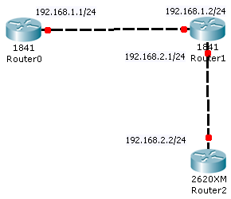
Lab Task

Task 1
Router 0
Router(config)#interface FastEthernet 0/0
Router(config-if)#ip address 192.168.1.1 255.255.255.0
Router(config-if)#no shutdown
Router 1
Router(config)#interface FastEthernet 0/0
Router(config-if)#ip address 192.168.1.2 255.255.255.0
Fig 10.1 shows the IP address to configure Static Route

Router(config-if)#no shutdown

Router(config)#interface fastethernet 0/1
Router(config-if)#ip address 192.168.2.1 255.255.255.0
Router(config-if)#no shutdown
Router 2
Router(config)#interface FastEthernet 0/0
Router(config-if)# ip address 192.168.2.2 255.255.255.0
Router(config-if)#no shutdown
Task 2
Router 0
Router(config)#ip route 192.168.2.0 255.255.255.0 192.168.1.2
Task 3
Router 2
Router(config)#ip route 192.168.1.0 255.255.255.0 192.168.2.1
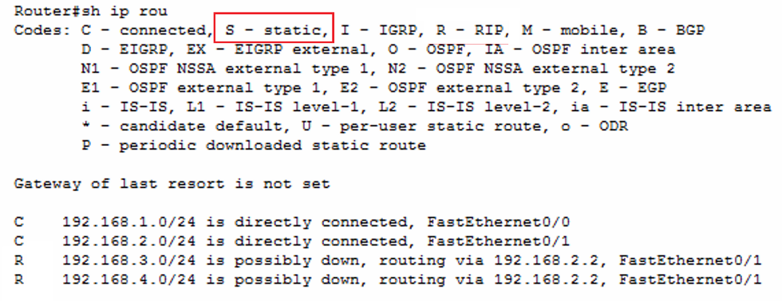
Task 4
Any Router
Router#show IP Route

LAB 11: Configuring WAN Connection and Default Routes

Objectives
- Serial connection explanation and configuration in packet tracer.
- Configuring router for default routes.
A. Configuring Serial Connections
The Serial connection is used to create a WAN connection with the help of a service provider who offers a dedicated leased line to its customers.
Business organizations buy leased lines to establish a WAN connection to connect with different offices and business sites that could physically be thousands of miles apart. Businesses have to pay for these leased lines according to the service availed. And accordingly, the service providers charge for this service i.e. based on the bandwidth they offer to their client organizations.
One of the connections used for a leased line is the Serial Connection in Cisco-based networks. If we have Cisco routers on both sides of the network then the default encapsulation known as HDLC will be used by the Cisco routers. However, this will not work with other brands' routers (i.e. with the non-Cisco routers) because this protocol is solely a Cisco proprietary.
If we want to establish a successful connection with a router of other vendors then we must configure the same data link protocol on both routers. If there will be a mismatch then a connection cannot be established and we will see the status of the interface as down under the data link.
If we are configuring a new Cisco router then by default the data link protocol would be HDLC however if we are configuring an old device then we should check the configuration and if there is a mismatch then we have to configure the same protocol on both routers.
Although HDLC works out of the box on all Cisco routers however it is not widely used because of its proprietary nature and it does not provide many features so PPP protocol is used by most organizations. Even on Cisco routers, organizations prefer the PPP protocol over the HDLC protocol due to its advanced features and benefits.
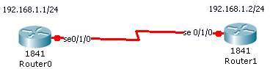
In this lab, we will configure a Serial Connection between the routers. We will set up a clock rate at 56000, which will provide a speed of 56 Kbps. In the real world, the DCE side of the cable is configured by the service provider. Generally, the clock speed is configured according to the availability of the bandwidth speed that the service provider is offering. The following lab uses a serial cable that will simulate a service provider. We will configure the clock speed on the Router that has the DCE side connected.

Lab Task of serial connections

Task 1
Router 0
Router(config)#interface serial 0/1/0
Router(config-if)# ip address 192.168.1.1 255.255.255.0
Router(config-if)# no shut

Task 2
Router 1
Router(config)#interface serial 0/1/0
Router(config-if)# ip address 192.168.1.2 255.255.255.0
Router(config-if)# no shut
Task 3
Router 0
Router(config-if)# clock rate 56000

B. Setting up Default Routes
Objectives
- Configuring default static route in Cisco packet tracer and discussing the role of the static route in networking.
Theoretical Description
A Default Static Route is configured on the routers so the traffic can be transferred to a default route if there is no entry in the routing table for a specific network.
Before sending packets to the other networks, routers check their routing table. The Router drops the packets if it is unable to find a specific route on which traffic should be sent. And when a router does not find the route in its routing table it sends the traffic to a default route, if that default route is configured. So basically, the traffic is sent out of the interface mentioned in the default route in the absence of an entry in the routing table for the traffic.
The default route is most useful when sending traffic to a public network like the Internet because it is not possible to have the routing table for the entire Internet. Hence, the default route helps the routers to send the packets going out to the internet.
In the local area network, when the destination address is not available in the local network then the data is sent out of the default gateway which is then routed to the other networks by routers; similarly, the default route helps to find the destination which is not available in the routing table.
In the below lab, we will create a default route on the Router to enable routing between different subnets.
The below network scenario is not common in the real world, we have just created this lab to show how the default route can route the traffic without the routing table however we can test the real default route in action if we configure the default route on the Router which is connected to the internet. In the packet tracer lab, we cannot emulate the internet so we are testing the default route in a simple network.
Note: we will only create a default route on the Router. After that, the Router should be able to route traffic. You can ping router 4 from router 0 to check the routing in action.
Command explanation – IP route 0.0.0.0 0.0.0.0 192.168.1.2
In the above command, 0.0.0.0 means that any IP address with any subnet mark should be sent out of interface 192.168.1.2 if a route is not present in the routing table.
Once we configure the default route, we can see the default route in the routing table with the S* symbol while static routes are shown with just the S symbol.
Before configuring the default route, you will see that the gateway of last resort is not set however once the default route is configured, the gateway of last resort is the Router's interface from which traffic will be sent out.
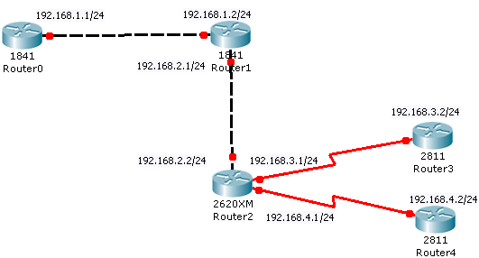
Fig 10.2 Default routes setup using serial connections
⁻

Lab Task of Default Routes

Task 1
Router 0
Router(config)#ip route 0.0.0.0 0.0.0.0 192.168.1.2

Task 2
Router 1
Router(config)#ip route 0.0.0.0 0.0.0.0 192.168.2.2
Task 3
Router 2
Router(config)#ip route 0.0.0.0 0.0.0.0 192.168.2.1
Task 4
Router 3
Router(config)#ip route 0.0.0.0 0.0.0.0 192.168.3.1
Router 5
Router(config)#ip route 0.0.0.0 0.0.0.0 192.168.4.1
Task 6
Router 0
Router#ping 192.168.4.2

LAB 12: Setting up Dynamic Routing Protocol RIP v1 and v2

Objectives
- Configure the hostname of a router.
- Configure the password for a router.
- We will configure three Cisco routers.
- We will enable these routers for dynamic routing using the RIP protocol.
Theoretical Description
Setting up router names and passwords

By default, the Cisco router is configured with the hostname 'router' and Switch is configured with the default hostname of 'switch' so we must change the default names of all the devices to make it relevant to the network diagram and this also makes it easy to understand and help us recognize the device when we are configuring the device.

It is the best practice to give hostnames to the devices according to the location for example if the Router is situated in the network then we can give the hostname as network followed by the model number [Network 1700] or we can give the hostname as per the role of the device for example If a router is connecting to the ISP then a good hostname can be ISP router.

Once a password is configured, users will be prompted to type in that password whenever they enter the Privileged Exec Mode. And if both the 'Enable Password' and 'Secret' are configured, then the users will have to access the Privileged Mode with 'Enable Secret' as enable secret is considered a superior password.

In this lab, we will also configure the Console line password and Auxiliary line password. To set up the Console line and Auxiliary line passwords we have to get under the line configuration mode of both lines.

We will also edit the hostname of our device. The device's name will instantly change when we enter the command – 'hostname device-name on the Command-line Interface. And to check the configured password for the privileged mode you have to exit back to the User Exec mode by simply typing Exit while on the Privileged mode. Then, you will have to type the password every time you enter into the Privileged mode.

You can check the password by initiating a Console connection once again. However, the Auxiliary line password cannot be simulated in the Packet Tracer.
Introduction to Routing Protocols
Static routing is not feasible in a large network. Hence, to implement routing in an easier way we can use dynamic routing protocols.

Routing information protocol (RIP) is one of the dynamic protocols that can be used for routing. The best part is that the Rip protocol is very easy to configure.

We will configure Rip version 2 in this lab.

RIP version 1 was introduced in 1988 when networks were comparatively simple that did not require complex routing. An earlier version of RIP had some limitations hence RIP version 2 was introduced in 1993 which improved some of the features of the RIP protocol. RIP is a distance-vector routing protocol and hops count to determine the route in the network. The RIP protocol only works till 15 hops and it does not work if the network is more than 15 hops away so this prevents RIP to work properly in a big network.

Major differences between versions 1 and 2

- RIP V2 supports classless networks, which means we can use VLSM [Variable length subnet mask] in our network while RIP V1 does not support subnetted networks.
- RIP V2 supports authentication while RIP V1 does not support authentication which makes RIP v1 prone to hacking attacks while Rip v2 provides added security while configuring the networks.
- RIP V2 uses multicast packets for routing updates while RIP V1 uses broadcast packets which increases unnecessary traffic in the network.

To configure RIP Ver2 on a router, we just have to type the "version 2" command after the "router rip" command to enable version 2 on any router. After configuring RIP version 2, we have to advertise the directly connected networks by using the command 'network id ' after enabling the RIP protocol on all the routers. Once the Rip protocol is configured properly you will be able to see the routes in the routing table, learned with the help of Rip protocol by the routers.

Below is an example of a route that is learned after configuring the RIP protocol:

R 192.168.2.0/24 [120/1] via 192.168.1.2, 00:00:28, FastEthernet0/0

You can verify and check routes in the routing table by using the command 'show IP route'.
We will also disable auto summarization by the Rip protocol.

Basic router configuration in packet tracer
Configuration of RIP protocol is very easy as compared to some of the link-state routing protocols like OSPF or EIGRP however RIP protocol does not offer that many features and RIP has a very simple working mechanism. RIP protocol uses hop counts when directing the traffic in the network.
RIP protocol is still widely used due to its simplicity and it is favored in small company networks where there is a fewer number of routers used small networks do not even need advanced routing protocols as they rarely use features that are provided by the advanced routing protocols while big companies with hundreds of Router and complex networks use advance routing protocols as they provide more features that are required for the stability and the functioning of the big networks so at the end it comes up to the requirement of the network.
To set up routers, we will assign an IP address to the router interfaces. It's the best practice to give a unique name to the Router, as well as describe the interfaces of the routers.
To enable the routing between routers we will use a basic routing protocol called Rip. After implementing the Rip protocol on all routers, we can look into the routing table of every Router to check if it has learned the routes with the help of the Rip protocol. We can check the routing table using the command 'show IP route'.
After the successful configuration of the routing protocol, we must see the routes in the routing table learned with the help of RIP and if we are unable to see the routes then we have to check the configuration and troubleshoot the issue with the configuration.
In Figure 9.1, check out the routes that are learned using RIP protocol by the Router, you should also make sure that Router should learn the routes of all the networks as shown.
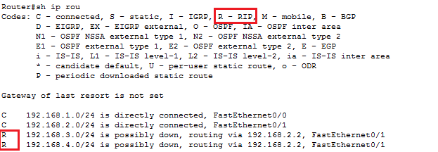
Fig 9.1 Router with IP routes connected and RIP implemented
R is representing the RIP protocol so all the routes having R in the front are learned by the Router via RIP protocol. By default, the RIP protocol auto-summarizes the routes so we have to disable the summarization on each Router.
We will also disable auto summarization of the routes in the routing table by using the command 'no auto-summary. Also, we will set up a MOTD banner on all the routers.
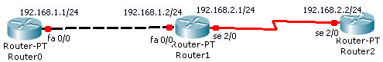

Fig 9.2 Routers connected with other Routers using RIP protocol

Use debug command to get the details :

# debug ip rip
>> Use this command to show all routes configured in router, say for router R1 :

R1# show ip route
>> Use this command to show all protocols configured in router, say for router R1 :

R1# show ip protocols

Lab Task

Task 1
Router(config)#hostname R1
R1(config)#

Task 2
R1(config)#enable password cisco

Task 3
R1(config)#enable secret cisco

Task 4
R1(config)#line con 0
R1(config-line)#password lab
R1(config-line)#login

Task 5
R1(config)#line aux 0
R1(config-line)#password ciscolab
R1(config-line)#login

Task 6 hostname
Router 0 | Router 1 | Router 2
Router(config)#hostname Islamabad | Router(config)#hostname Lahore | Router(config)#hostname Karachi

Task 7 IP address to router interfaces
Router 0 | Router 1 | Router 2
Router(config)#in fa 0/0  Router(config-if)#ip add 192.168.1.1 255.255.255.0  Router(config-if)#no sh | Router(config)#in fa 0/0  Router(config-if)#ip add 192.168.1.2 255.255.255.0  Router(config-if)#no sh  Router(config-if)#in se 2/0  Router(config-if)#ip add 192.168.2.1 255.255.255.0  Router(config-if)#no sh  Router(config-if)#clock rate 56000 | Router(config)#in se 2/0  Router(config-if)#ip add 192.168.2.2 255.255.255.0  Router(config-if)# no sh

Task 8
Router 0 | Router 1 | Router 2
Router(config)#router rip  Router(config-router)#ver 1  Router(config-router)#network 192.168.1.0  Router(config-router)#no auto-summary | Router(config)#router rip  Router(config-router)#ver 1  Router(config-router)#network 192.168.1.0  Router(config-router)#network 192.168.2.0  Router(config-router)#no auto-summary | Router(config)#router rip  Router(config-router)#ver 1  Router(config-router)#network 192.168.2.0  Router(config-router)#no auto-summary  Router(config)#interface fastEthernet 0/0  Router(config-if)#ip address 192.168.1.1 255.255.255.0  Router(config-if)#no shutdown

Task 9
Router 0 | Router 1 | Router 2
Router(config)#in fa 0/0  Router(config-if)#description connection to headquarter | Router(config)#in fa 0/0  Router(config-if)#description connection to branch 1  Router(config)#in se 2/0  Router(config-if)#description connection to branch 2 | Router(config)#in se 2/0  Router(config-if)#description connection to headquarter

Task 10 On all routers set MOTD
Router(config)#banner motd / —- UNAUTHORIZED ACCESS IS NT ALLOWED —- /

LAB 13: Simulation of IoT based Home Automation

Objectives
- Configure the IoT devices.
- Control the devices (On/Off) through mobile/wireless device.

Theory:

Cisco Packet Tracer has evolved to include support for IoT (Internet of Things) devices, allowing users to create and simulate IoT networks along with traditional networking components. Here’s an overview of how IoT devices are utilized within Cisco Packet Tracer:

Types of IoT Devices in Packet Tracer

Smart Devices:
- Smart Lights: Can be controlled remotely or programmed to respond to environmental changes.
- Smart Thermostats: Adjusts heating/cooling settings based on predefined conditions or remote commands.
- Smart Doors/Locks: Access control through remote commands or sensor inputs.
- Smart Alarms: Integrated with sensors to trigger alarms based on specific events.
Sensors:
- Temperature Sensors: Measure and report temperature readings.
- Motion Sensors: Detect movement and can trigger actions or alerts.
- Humidity Sensors: Measure the level of humidity in the environment.
- Light Sensors: Detect the intensity of light and can be used to control lighting.
Actuators:
- Motors: Used in various applications like opening/closing doors or windows.
- Sprinklers: Can be activated based on sensor input (e.g., soil moisture sensors).
Controllers and Gateways:
- Microcontrollers: Simulate the control logic for IoT devices (e.g., Arduino-like devices).
- IoT Gateways: Bridge IoT devices to the network, allowing communication and control.
Miscellaneous:
- Wearable Devices: Simulate fitness trackers or smartwatches.
- Smart Appliances: Simulate devices like smart refrigerators or ovens.

The following figure illustrates the IoT devices installed in smart homes and connected to the home gateway.
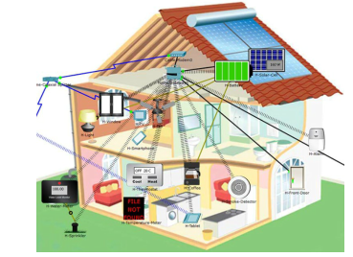

Firstly, select Home icon at the left bottom corner and now choose the required Home components.
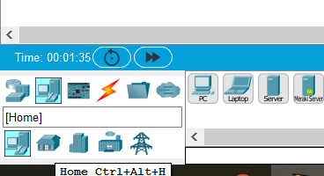

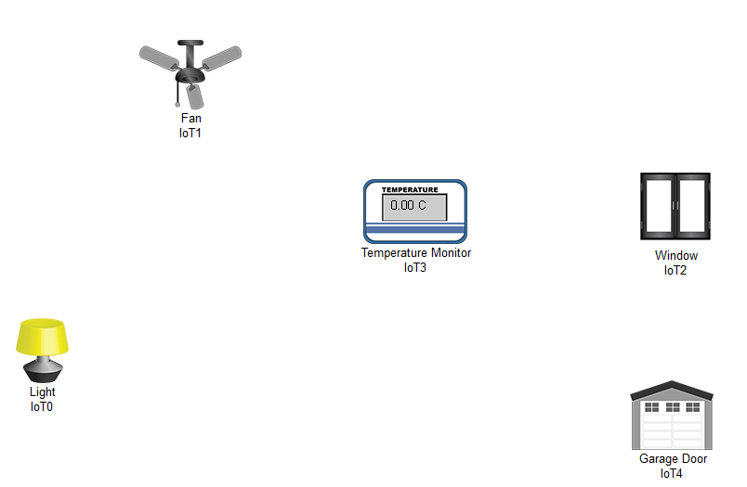

Additionally, you can change the name of Appliances by clicking on respective Appliances and select the config option. You have to repeat the same steps to rename the other devices too.

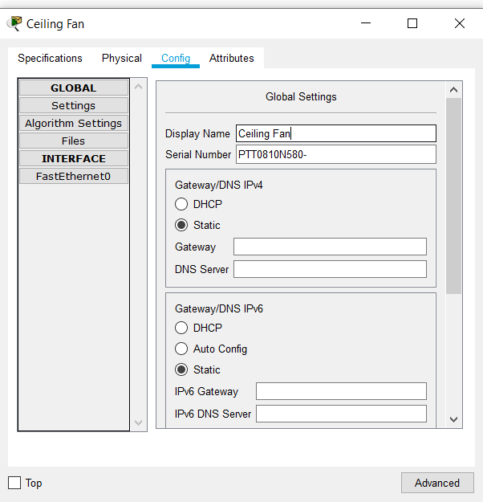

Thus now let’s establish a wireless connection. Go to Wireless devices and choose Home Gateway

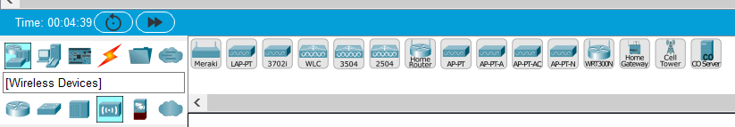

Now copy the SSID of Home Gateway by clicking on the Home gateway.
Then paste the SSID In each appliance by clicking on the config option. Similarly repeat the steps for other devices as well.
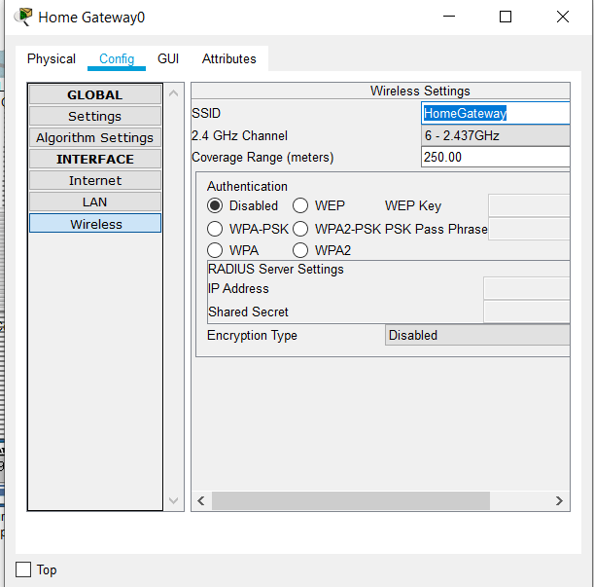

Now let’s select IOT server as Home gateway to all appliances.
Click on Appliances->select Advanced->config->choose Home Gateway. Similarly repeat the steps for other devices as well.

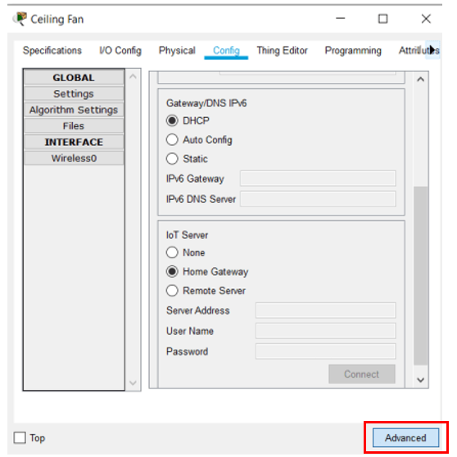

Thus you can notice that all devices are connected to the Home Gateway

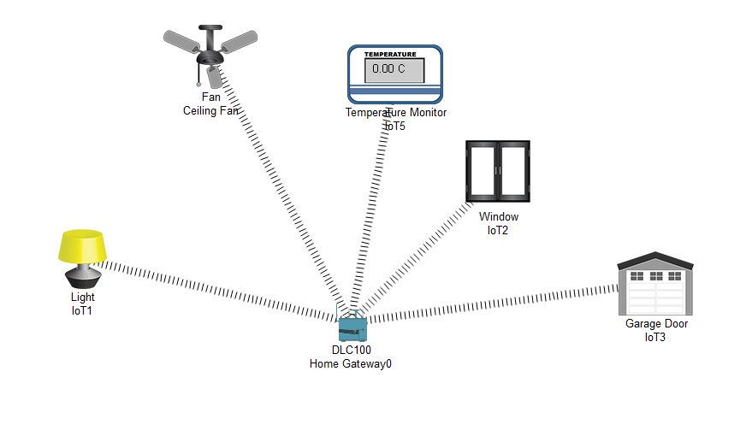
Now select smart device to Control and Monitor Appliances.
Select end devices at bottom left corner

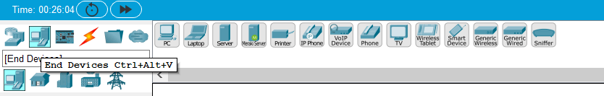

Now connect your smart device also to your Home gateway


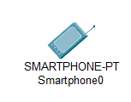
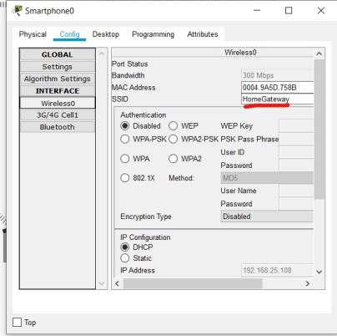

Thus your smart device is connected to your Home Gateway. Click on smart device and choose Desktop. You can now login.

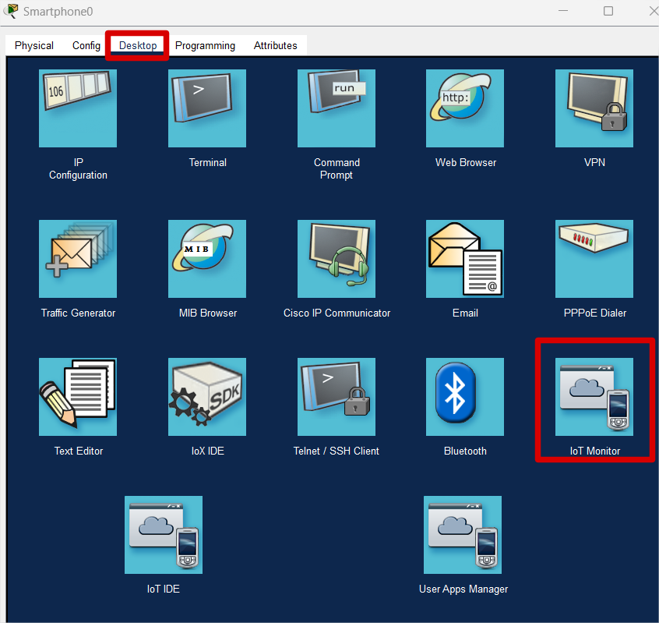
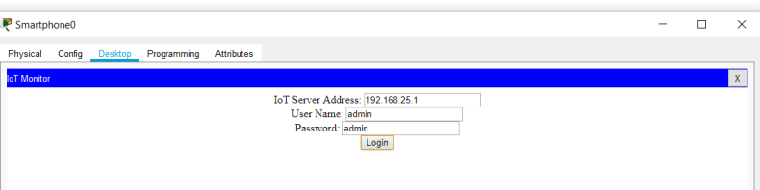

Finally, you can control and Monitor in the Dashboard.

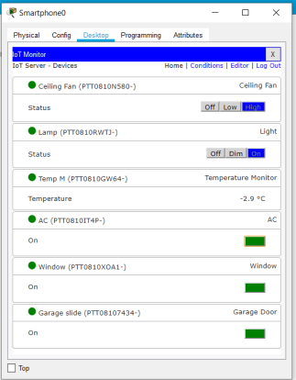

Lab Tasks

- Perform the Lab task and attach it along with the lab report while submitting.
- Change the SSID of the Homegateway to MyHome and connect with solar panel, water level monitor, webcam, smoke detector and window.

LAB 14: Programming and controlling the IoT devices using MCU and SBC

Objectives
- Connect the IoT Devices with the MCU-PT
- Program MCU-PT to control the IoT devices.
Theory:
Microcontroller Unit (MCU)
A Microcontroller Unit (MCU) is a compact integrated circuit designed to govern a specific operation in an embedded system. It typically includes a processor, memory, and input/output peripherals on a single chip, which makes it a complete computer system on a small scale.

MCU Hardware
- Often a low-power CPU core such as ARM Cortex-M0, M3, M4, or M7, AVR, PIC, etc.
- Clock speeds ranging from a few MHz to several hundred MHz (e.g., 48 MHz for ARM Cortex-M0, up to 480 MHz for ARM Cortex-M7).
- Clock speeds ranging from a few MHz to several hundred MHz (e.g., 48 MHz for ARM Cortex-M0, up to 480 MHz for ARM Cortex-M7).
- RAM: 2KB to 512KB (used for data storage during execution).
- RAM: 2KB to 512KB (used for data storage during execution).
- ADC (Analog-to-Digital Converter) channels, typically 8 to 16, with 8- to 12-bit resolution.
- GPIO Pins: Configurable for digital input or output.
- UART (Universal Asynchronous Receiver/Transmitter).
- I2C (Inter-Integrated Circuit).
- SPI (Serial Peripheral Interface).
- CAN (Controller Area Network) for automotive applications.
- USB (Universal Serial Bus), often USB 2.0.
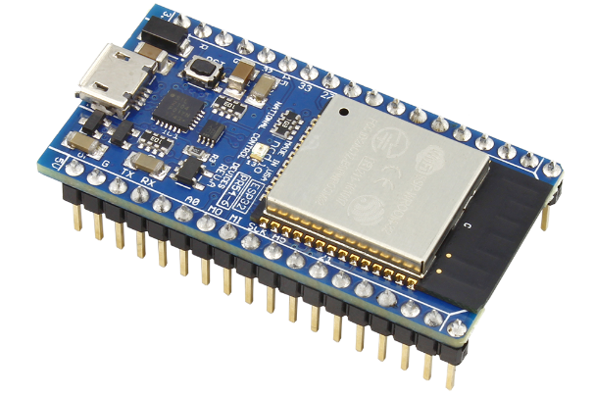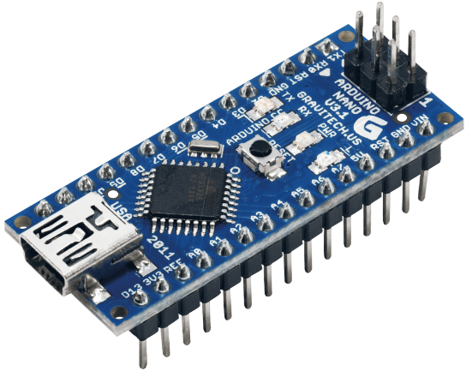

Raspberry Pi
The Raspberry Pi is a small and inexpensive single-board computer (SBC), offers a low-cost, versatile platform suitable for a wide range of applications, from simple learning projects to complex, industrial-level tasks.
Raspberry Pi Hardware
The Raspberry Pi and its Ports
- It has a number of USB ports that can be used to connect various devices including keyboards, mouse, external drives and cameras.
- The Pi includes an 10/100Mbps Ethernet port and 40 GPIO pins, operating at 3.3V.
- Other Pi ports include an audio out, a micro SD card slot, and a micro USB (used for power) connector.
The Pi3 also adds:
- 1.2 Ghz 64-bit quad-core ARMv8 CPU
- 802.11n Wireless LAN
- Bluetooth 4.1
- Bluetooth Low Energy (BLF)
The Pi can run a number of operating systems, including Linux and Windows.
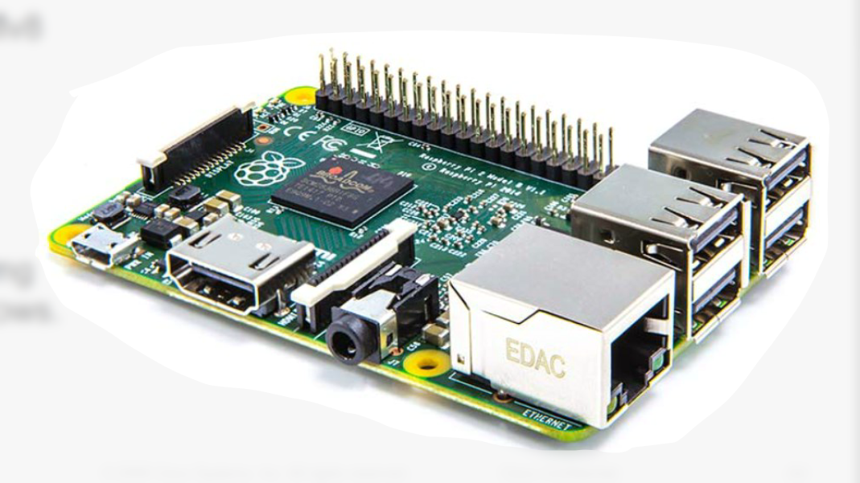

Blockly
Blockly allows the creation of a program without entering any lines of code; it uses colored blocks. Blocks can be connected together by dragging and attaching the appropriate blocks. Creating a new variable in Blockly is a simple matter of dragging the variable block and filling in the value slot.

IF-THEN
- Used to allow the code to make decisions.
- FOR Loops
- Used to repeat the execution of a block of
- Code for a specific number of times.
- WHILE Loops
- Used to execute a block of code while a
- Condition is true.
Click on the Components category, then click MCU Board and drag it to the workspace.
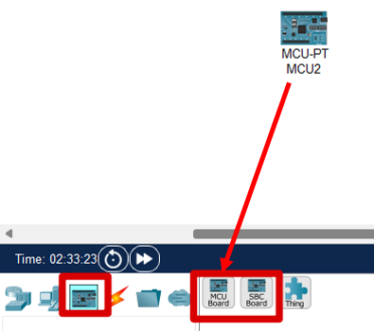
Click the subcategory Actuators, select LED and drag it to the workspace.
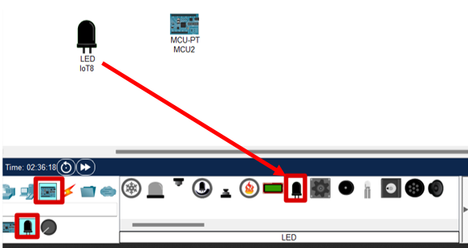
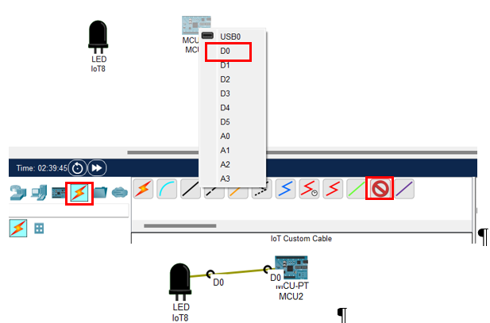
Double click the MCU. Click the Programming tab. (If you do not see the Programming tab, click the Advanced button at the lower right corner.)
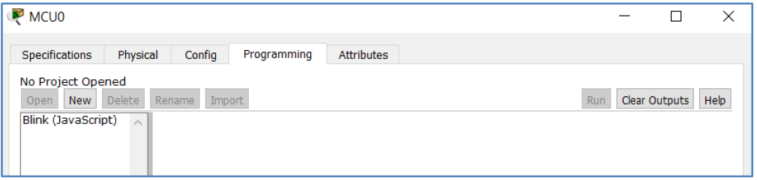
Examine a prebuilt Blockly program
Under the note No Project Opened, click New. In the Create Project window, enter Blinking LED as the project name. In the Template dropdown menu, select Blink – Visual.

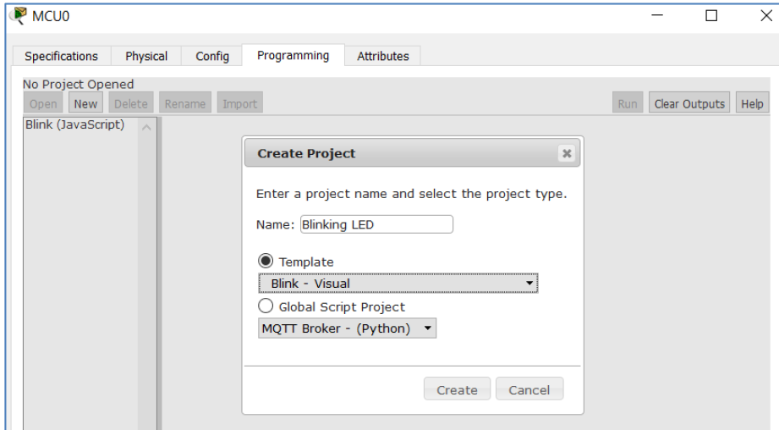

Click Create.

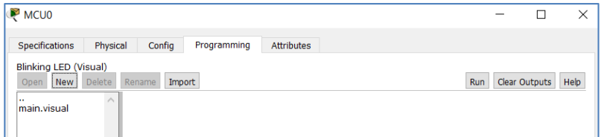

Double-click main.visual. The prebuilt Blockly program displays.

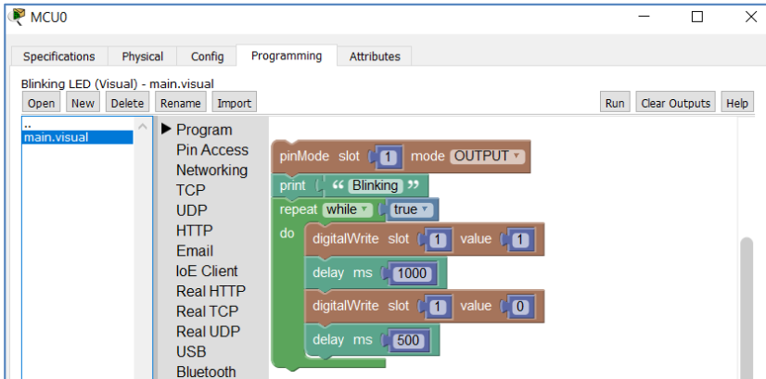

Change the Value field of the first digitalWrite block to 1023.

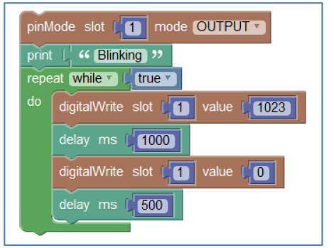
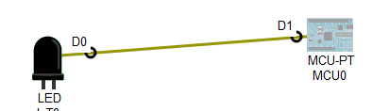
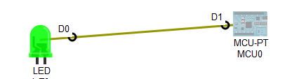

Control an RGB LED using Blockly
An RGB can display different colors with the combination of red, green, and blue.

Add an MCU and an RGB LED.
In Step 1, you add another MCU board and a RGB LED into the workspace.
Click the subcategory Actuators, select RGB LED and drag it to the workspace. Add another MCU board

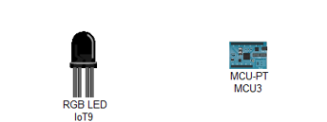
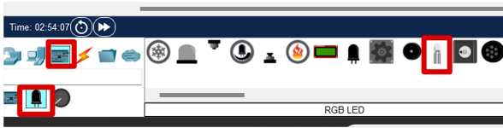

Click the Connections category, select three IoT Custom Cables to link MCU and RGB LED.
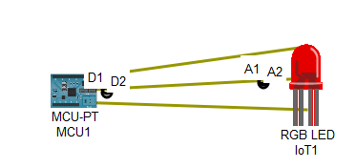
Open the prebuilt Blockly program. Click MCU -> Programming. Under the note No Project Opened, click New. In the Create Project window, enter Blinking RGB LED as the project name. In the Template dropdown menu, select Blink – Visual.
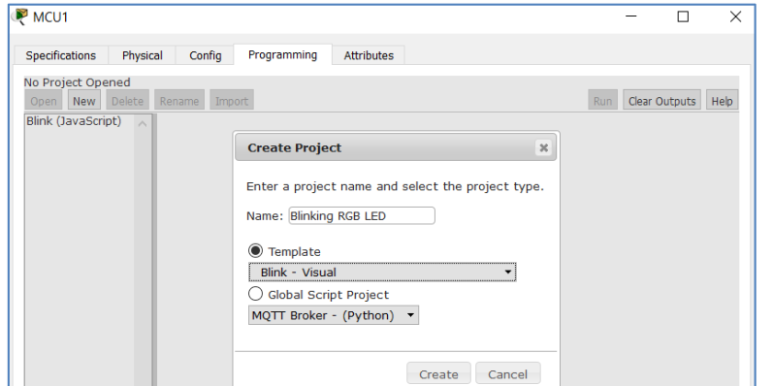
Click Create. Double-click main.visual. The prebuilt Blockly program displays.
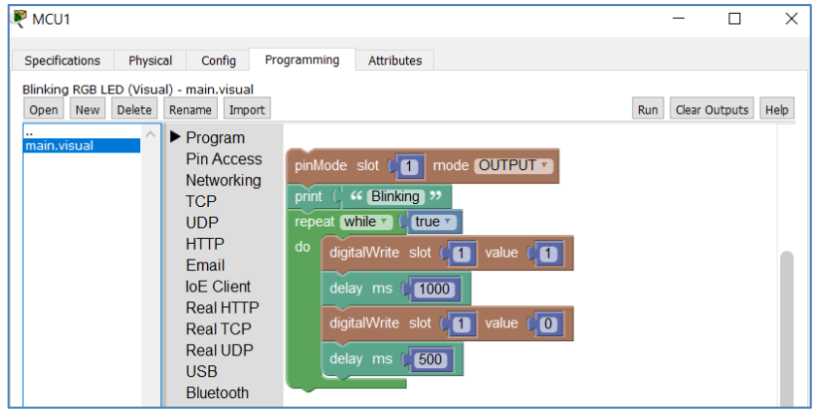

Modify the Blockly program
Expand Pin Access group, and add two more pinMode blocks to set three slots as OUTPUT (from MCB to send a signal to RGB LED).
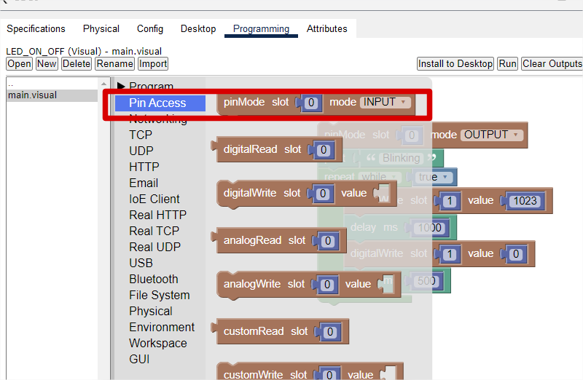
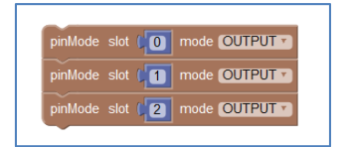
From the Pin Access group, select analogWrite blocks to replace digitalWrite blocks. Also, add a few print blocks.
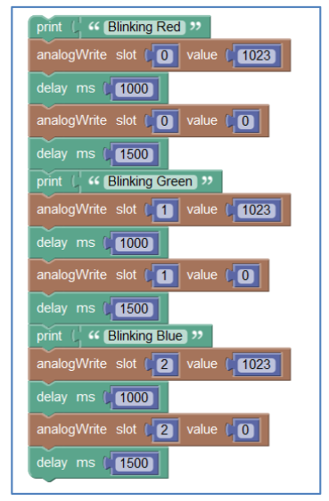
The final program is as follows:
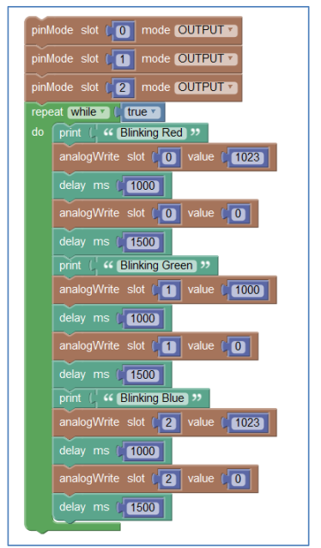
Run the program. The LED should display RED, GREEN, and BLUE in sequence.
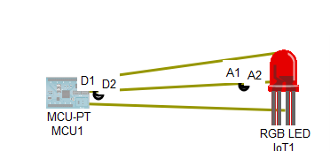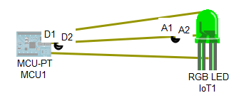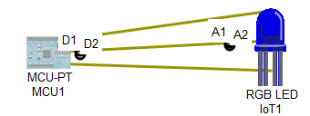

Lab Task
Modify the program to show a combined color from all three inputs with different values for each slot.

Appendix ‘A’ Writing a Lab Report

- Overview
This document describes a general format for lab reports that a student should adopt and is recommended. This document may describe the labs of computer networks but this is only a helpful document and explains about writing a lab report.

Lab reports are the most frequent kind of document written in any domain and can count for as much as 20% of lab marks. Yet, if little time or attention is devoted to how to write them will help the student to attain the above-mentioned marks. Worse yet, each teacher wants something a little different.

Regardless of variations, however, the goal of lab reports remains the same: document your findings and communicate their significance. With that in mind, we can describe the report's format and basic components. Knowing the pieces and purpose, you can adapt to the particular needs of a course or a teacher.
A good lab report does more than present results or tasks; it demonstrates the writer's comprehension of the concepts behind the Lab work. Merely recording the expected and observed work is not suffice; you should also identify how and why differences occurred, explain how they affected your task, and shows your understanding of the task at hand.
Bear in mind that a format, however helpful, cannot replace clear thinking and organized writing. You still need to organize your ideas carefully and express them coherently.
- Typical Components

- Font and Size
The report should be written in Times New Roman, font size 10, whereas, the headings should be in BOLD with proper numbering bullets e.g. 1.0, 2.0, 3.0 with a subheading level 2 as 1.1, 1.2, 2.1, 2.2. Whereas, level 3 headings as 1.1.1, 1.1.2, 2.1.1, and so on.
- Header and Footer
Lab Report header should contain; Roll No. XXXXX (Left), (Spring XX) (Mid), Lab X (Right)
Lab Report Footer should contain; Computer Networks (Left), Software Engineering Department (Mid), Page No. X out of Total (Right) e.g, Page 9 | 12
NOTE: Remember to add “Different first page” from Layout > Page setup, if the first page is desired by an instructor.
- Main Document Body
- Lab Title Heading
- Abstract of the Lab
- Equipment required for the Lab
- Introduction to the Lab
- Lab Task
  - Tasks chronology
  - Transcribing task results
  - Discussion on tasks
- Conclusion
- Appendices
1. The Title Heading needs to contain Lab No. X top Center, BOLD, Name of the Lab. The title should be as mentioned in the lab manual (i.e. "Lab No.1: Preparing Ethernet Cables".
2. The Abstract summarizes four essential aspects of the report: the purpose/Objective of the lab, what did you learn from the lab, and the major conclusion. The abstract often also includes a brief reference to the theory behind the learning or methodology. The information should enable readers to decide whether they need to read your whole report. The abstract should be one paragraph of 100-200 words.
Quick Abstract
Must have:
1. Purpose
2. Leaning aspect
3. Major conclusion
May include:
1. Brief method
2. Brief theory
Restrictions:
ONE page 200 words MAX

3. Equipment required for Lab
Mention hardware and software as subheadings
Equipment can usually be a simple list, but make sure it is accurate and complete. In some cases, you can simply direct the reader to a lab No, of manual or standard procedure: "Equipment was set up as in Lab manual."
Quick Intro
Must Have:
1. Purpose of the Lab
2. Important background and/or theory
May include:
1. Description of specialized equipment
2. Justification of experiment's importance
4. The Introduction is more narrowly focused than the abstract meaning it elaborates on each aspect covered during a specific lab. It states the objective of the lab and provides the reader with background on why this lab is important. State the topic of your lab clearly and concisely, in one or two sentences:

Note on Verb Tense
Introductions often create difficulties for students who struggle with keeping verb tenses straight. These two points should help you navigate the introduction:
- The experiment is already finished. Use the past tense when talking about the experiment.
"The objective of the lab was..."
- The lab, the theory, and the equipment used still exist; therefore, these get the present tense:
"The purpose of this lab is..."
"The results of the ping command enlist..."
"The command executed on router1 displays...

5. Lab Tasks describe the process in chronological order. Using a clear paragraph structure, explain and attach all steps in the order as happened. If the instructor asks, you can simply state that you followed the procedure mentioned in some X or Y lab of the manual or labs earlier performed. For example, the router was configured as mentioned in lab 7 or the switch was configured as per lab No. X.
Be sure you still document occasions when you did not follow the instructions exactly. If you've done it right, another student should be able to duplicate your experiment.
A student should at least write a minimum of two precautions while documenting performed tasks, in the task section.
Transcribing Task Results are usually dominated by tables, and figures; however, you still need to state all performed tasks explicitly in verbal form.
Graphics need to be clear, easily read, and well labeled (e.g. Figure 1: router on the stick). An important strategy for making your lab work effective is to draw the reader's attention to them with a sentence or two, so the reader has a focus when reading the graph.
In most cases, providing a sample figure is sufficient in the report. Leave the remainder in an appendix. Likewise, if you have raw data it can be placed in an appendix. Refer to appendices as necessary, pointing out trends and identifying special features.
Discuss is the most important part of your Lab, you show that you understand the lab beyond the simple level of completing it. Explain tasks, some people like to think of this as the "subjective" part of the report. By that, they mean this is what is not readily observable. This part of the lab focuses on the question of understanding "What is the significance of the task, what have you learned, and why it is important to learn?" To answer this question explain it in the discussion:

More particularly, focus your discussion with strategies like these:
2. Interpretation
What is the significance of the lab? What ambiguities exist?
What questions might we raise?
Find logical explanations for problems in the data:

1. Analysis
What do the lab task indicate clearly?
What have you found?
Explain what you know with certainty based on your results and draw conclusions:

6. Conclusion can be very short in most undergraduate labs. Simply state what you know now for sure, after performing the lab:
7. Appendices typically include such elements as raw data, calculations, graphs pictures, or tables that have not been included in the report itself. Each kind of item should be contained in a separate appendix.
Make sure students refer to each Appendix at least once in your report. For example, the task section of lab 1 might state during the discussion: “the categories of the UTP and STP cables are contained in Appendix A.

Appendix ‘B’ Evaluation Rubrics


National University of Modern Languages

Sector H-9, Islamabad, Pakistan.

Department of Software Engineering

Course Title: Student Name
Roll Number: Lab Number: Date:
Lab Assessment Rubrics (Open Ended Lab/Project/Lab Final)
Method: Lab report and instructor observation during Lab session

Formatting (5 marks) |  | Good  Performance | Satisfactory  Performance | Unsatisfactory  Performance
 |  | (1) | (0.5) | (0)
1. | Headings
2. | Header & footer
3. | Figure captions
4. | Task chronological order
5. | Precautions
Content (5 marks) |  | Good  Performance | Satisfactory  Performance | Unsatisfactory  Performance
 |  | (1) | (0.5) | (0)
1. | Topic introduction
2. | Task content
3. | Precaution
4. | Clarity of tasks & figures
5. | Conclusion
Tasks (10 marks) |  | Good  Performance | Satisfactory  Performance | Unsatisfactory  Performance
 |  | (4-5) | (2-3) | (0-1)
1. | Performed all given tasks
2. | Subparts are shown with task
PKT File (5 marks) |  | Good  Performance | Satisfactory  Performance | Unsatisfactory  Performance
 |  | (4-5) | (2-3) | (0-1)
1. | The file is opening + All tasks are running
Total Marks Obtained:__________out of 25
Instructor’s Signature: ___________________


National University of Modern Languages

Sector H-9, Islamabad, Pakistan.

Department of Software Engineering

Course Title: Student Name
Roll Number: Lab Number: Date:
Lab Assessment Rubrics
Method: Lab report and instructor observation during Lab session

Formatting (5 marks) |  |  | Good  Performance | Satisfactory  Performance | Unsatisfactory  Performance
 |  |  | (1) | (0.5) | (0)
1. | Headings
2. | Header & footer
3. | Figure caption
4. | Task chornological order
5. | Precautions
Content (5 marks) |  |  | Good  Performance | Satisfactory  Performance | Unsatisfactory  Performance
 |  |  | (1) | (0.5) | (0)
1. | Topic introduction
2. | Task content
3. | Precaution
4. | Clarity of task & figures
5. | Conclusion
Tasks (10 marks) |  |  | Good  Performance | Satisfactory  Performance | Unsatisfactory  Performance
 |  |  | (4-5) | (2-3) | (0-1)
1. | Performed all given tasks
2. | Subparts are shown with task

Total Marks Obtained:___________ out of 20
Instructor’s Signature: ___________________

